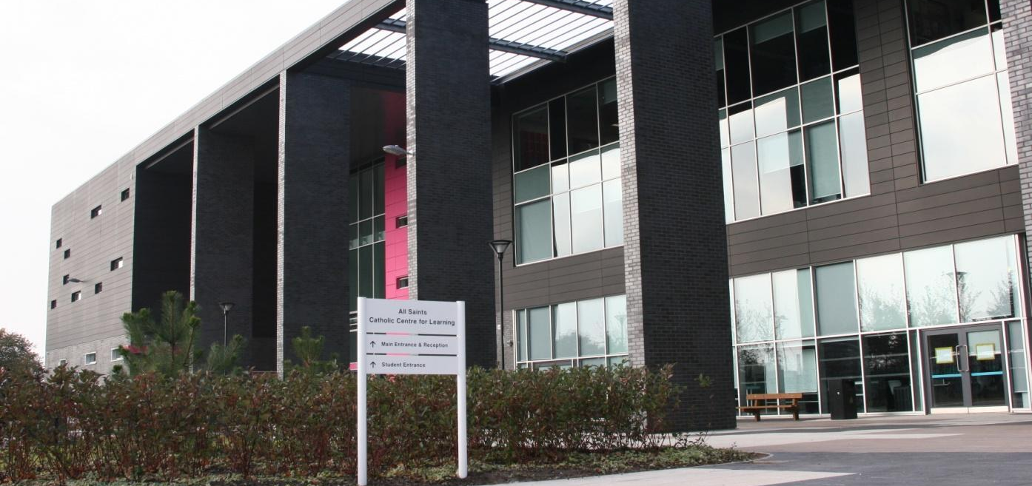
ALL SAINTS CATHOLIC HIGH SCHOOL

SAFEGUARDING
AND CHILD PROTECTION POLICY AND PROCEDURES

“We will provide a Christian Education for all pupils based on the teachings of Jesus and the Spirit of the Gospels. The whole life of the school will be determined by the Gospel Values of Love and Justice. We will always value and care for all members of the All Saints Community according to their needs, and will affirm and nurture the development of all”

School Mission Statement

Date Reviewed: September 2021

Next Review Date: September 2022
ALL SAINTS CATHOLIC HIGH SCHOOL

SAFEGUARDING TEAM 2021-2022

Designated Safeguarding Lead (DSL) for Child Protection is:
Miss Lynne Jackson

Deputy Designated Persons for Child Protection are:

Assistant Principal/SENCO
Mr Brian Bradley

Headteacher
Mr Tony McGuinness

Other members of the Safeguarding Team are:

Designated Teacher for Children Looked After (CLA)
Mrs Katie Towler

Anti-Bullying and Online Safety Co-ordinator
Mrs Karen Currie

Designated Child Protection Governor

All members of the Safeguarding Team can be contacted via All Saints Catholic High School, telephone number: 0151 477 8740 or 0151 477 8751

The aim of this policy is to promote a safe environment where safeguarding children concerns can be managed in an appropriate and timely way. The policy reflects current legislation, statutory guidance and complies with best practice standards and Ofsted requirements in relation to child protection and safeguarding in schools.

Schools and colleges and their staff are an important part of the wider safeguarding system for children.
Para. 1 Keeping Children Safe in Education, September 2021.

STATEMENT

All Saints Catholic High School recognises our moral and statutory responsibility to safeguard and promote the welfare of all pupils. We endeavour to provide a safe and welcoming environment where children are respected and valued. We maintain an attitude of “it could happen here” where safeguarding is concerned. We are alert to the signs of abuse and neglect and follow our procedures to ensure that children and young people receive effective support, protection and justice. The procedures contained in this policy apply to all staff, volunteers and governors and inform parents/carers how we will safeguard their children whilst they are in our care.

POLICY PRINCIPLES

- The welfare and interests of the child are paramount.
- All children, regardless of age, gender, identity, ability, culture, ethnicity, language, religion or beliefs, disability, sexual orientation or socio-economic backgrounds have equal rights to protection.
- Children should be listened to and their views and wishes should inform any assessment and provision for them. Staff should always act in the interests of the child in order to protect them.
- All staff have a key role in prevention of harm and an equal responsibility to act on any suspicion or disclosure that may suggest a child is at risk of harm.
- We acknowledge that working with other agencies protects children and reduces risk and so we will engage in partnership working to promote the welfare of children and safeguard them.
- The school will follow the Local Authority and Knowsley Safeguarding Children Partnership (KSCP) procedures and will provide them with information as required.
- Whilst we will work openly with parents/carers as far as possible, All Saints Catholic High School reserves the right to contact children’s social care (CSC) or the police, without notifying parents/carers if this is in the child’s best interests.
- Pupils, staff and families involved in child protection issues will receive appropriate support.
- Children have a right to learn ways to keep themselves safe from harm and exploitation.
Safeguarding and promoting the welfare of children is everyone’s responsibility. Everyone who comes into contact with children and their families has a role to play. In order to fulfil this responsibility effectively, all professionals should make sure their approach is child-centred. This means that they should consider, at all times, what is in the best interests of the child.

Para. 2 - Keeping Children Safe in Education, September 2021.

Our school understands that some children, including those with special educational needs and disabilities (SEND), can be particularly vulnerable to abuse and we accept the responsibility to take reasonable and appropriate steps to ensure their welfare.

…“additional barriers can exist when recognising abuse and neglect in this group of children. These can include:
- assumptions that indications of possible abuse such as behaviour, mood and injury relate to
the child’s disability without further exploration;
- being more prone to peer group isolation than other children;
- the potential for children with SEN and disabilities can be disproportionally impacted by
behaviours such as bullying, without outwardly showing any signs; and
- communication barriers and difficulties in overcoming these barriers.”
Para. 185 - Keeping Children Safe in Education, September 2021.

POLICY AIMS

- To promote and prioritise the safety and wellbeing of children and young people.
- For all pupils to have a sense of being valued and cared for.
- To ensure everyone understands their roles and responsibilities in respect of safeguarding and child protection. See Appendix 1.
- To ensure all staff have read Part 1 and Annex A of Keeping Children Safe in Education, September 2021 guidance document and have completed a signed record to say they have done so.
- To ensure everyone is provided with appropriate learning opportunities to recognise, identify and respond to signs of abuse, neglect and other safeguarding concerns relating to children and young people.
- To ensure everyone recognises that even if there are no reported cases of peer-on-peer abuse in our school, such abuse may still be taking place and just not being reported.
- To ensure appropriate action is taken in the event of incidents/concerns of abuse and support provided to the individual/s who raise or disclose the concern.
- To ensure that confidential, detailed and accurate records of all safeguarding concerns are maintained and securely stored.
- To prevent the employment/deployment of unsuitable individuals.
- To help protect children and young people from exploitation including sexual and criminal exploitation (county lines) and radicalisation.
- To ensure robust safeguarding arrangements and procedures are in operation.

The policy and procedures will be widely promoted and are mandatory for everyone involved in school. Failure to comply with the policy and procedures will be addressed without delay and may ultimately result in dismissal/exclusion from All Saints Catholic High School, as detailed in the Staff Code of Conduct, Allegations Management Policy and school’s Behaviour Policy.

DEFINITION OF ABUSE

Abuse: a form of maltreatment of a child. Somebody may abuse or neglect a child by inflicting harm or by failing to act to prevent harm. Children may be abused in a family or in an institutional or community setting by those known to them or, more rarely, by others. Abuse can take place wholly online, or technology may be used to facilitate offline abuse. They may be abused by an adult or adults or another child or children.”

Types of abuse and neglect include:
Physical Abuse Emotional Abuse

Sexual Abuse Neglect
Full details of definitions can be found in Appendix 6 and for further specific safeguarding issues see Appendix 4.

In line with Keeping Children Safe in Education 2021, the definition of safeguarding and promoting the welfare of children for this document is as follows:

- Protecting children from maltreatment
- Preventing impairment of children’s health or development
- Ensuring that children grow up in circumstances consistent with the provision of safe and effective care
- Taking action to enable all children to have the best outcomes

Para. 4 – Keeping Children Safe in Education, September 2021.

Staff have a particular contribution to make in listening to children and young people who have experienced abuse. This should be valued and recognised; however, it is understood that this work will not be undertaken at a time when it may impact on any legal processes through which the child may be involved.

All Saints Catholic High School recognises that children who are abused or who witness domestic abuse may find it difficult to develop a sense of self-worth. They may feel helpless, humiliated and hold some sense of blame. School may be the only stable, secure and predictable element in the lives of children and young people who are at risk so our school will endeavour to support pupils by:
- Establishing and maintaining an environment where children and young people feel safe, secure and are encouraged to talk and feel listened to.
- Ensuring children and young people know there are adults in school they can talk to if they are worried.
- Ensuring that the content of the curriculum encourages self-esteem and self-motivation and children and young people are taught the skills they need to recognise and stay safe from all kinds of harm.
- Ensuring that children and young people who may be particularly vulnerable, such as those with SEND, are supported.
- Ensuring that children and young people who have English as an additional language have access to support and information that is clear, accessible and in their preferred language.
- Recognising that children and young people living in environments where they may be exposed to Adverse Childhood Experiences (ACEs), such as domestic abuse, adult drug/alcohol misuse, adult mental health issues and/or criminality are vulnerable and may be in need of support and protection.
- Ensuring all of our school’s policies are upheld and procedures are applied appropriately.
- Identifying a designated safeguarding lead and two deputy designated persons.
- Identifying a key member of staff as an Operation Encompass champion whose role is to receive information from the police relating to incidents of domestic abuse.
- Monitoring the welfare of children and young people and notifying CSC via the Multi-agency Safeguarding Hub (MASH) as soon as there is a child protection concern.
- Using a Signs of Safety approach to support the safeguarding of children and families.
- Using assessment tools such as the Graded Care Profile 2 when they are concerned that a child may be experiencing neglect.
- Initiating and contributing to assessments relating to the child/young person and their family, including Early Help Assessments in line with the Knowsley: Helping Children Thrive 2020.

School and college staff are particularly important as they are in a position to identify concerns early, provide help for children and prevent concerns from escalating. Schools and colleges should work with social care, the police, health services and other services to promote the welfare of children and protect them from harm.

Para. 6 & 103 - Keeping Children Safe in Education, September 2021.

CHILDREN WHO MAY BE PARTICULARLY VULNERABLE

To ensure that all of our pupils receive equal protection, we will give special consideration to children who:
- are disabled, have certain health conditions and specific additional needs
- have special educational needs (whether or not they have a statutory Education Health Care Plan)
- have a mental health need
- are young carers
- are showing signs of being drawn into anti-social or criminal behaviour, including gang involvement and association with organised crime groups or county lines
- are frequently missing/go missing from care or from home
- are at risk of modern slavery, trafficking, sexual or criminal exploitation
- are at risk of being radicalised or exploited
- have a family member in prison or are affected by parental offending
- are affected by family circumstances such substance misuse, domestic abuse or parental mental health problems
- are misusing drugs or alcohol themselves
- have returned home to their family from care
- are at risk of ‘honour’-based abuse such a Female Genital Mutilation or forced marriage
- are privately fostered
- are persistently absent from education, including absence for part of the school day.

ADVERSE CHILDHOOD EXPERIENCES (ACEs)

ACEs are potentially traumatic events that occur in childhood. They can include violence, abuse, neglect, growing up in a family with mental health or substance use problems or having a family member attempt or die from suicide. Toxic stress from ACEs can change brain development and affect how the body responds to stress. When children are exposed to ACEs it can have a long-lasting impact on their ability to think, interact with others and on their learning and on future violence victimization and perpetration. ACEs are linked to chronic health problems, mental illness, and substance misuse in adulthood and can also negatively impact education, job opportunities, and earning potential; however, they can be prevented.

The presence of ACEs does not mean that a child will automatically experience poor outcomes. Children’s positive experiences or protective factors can prevent them from experiencing adversity and can protect against many of the negative health and life outcomes even after adversity has occurred. It is important to address the conditions that put children and families at risk of ACEs so that they can be prevented before they happen.

BULLYING

While bullying between children is not a separate category of abuse and neglect, it is a very serious issue that can cause considerable anxiety and distress. At its most serious level, bullying can have a disastrous effect on a child’s wellbeing.

All incidences of bullying, including cyber-bullying and prejudice-based bullying should be reported and will be managed through our anti-bullying procedures. Our school’s Anti-Bullying Co-ordinator is Mrs Karen Currie but if the bullying is particularly serious, the headteacher and the DSL may consider implementing child protection procedures.

CHILD EXPLOITATION

Child Criminal Exploitation (CCE) or County Lines
County lines is a term used to describe gangs and organised criminal networks involved in exporting illegal drugs into one or more importing areas within the UK, using dedicated mobile phone lines or other form of “deal line”. They are likely to exploit children and vulnerable adults to move and store the drugs and money and they will often use coercion, intimidation, violence (including sexual violence) and weapons.

Criminal Exploitation of Children and Vulnerable Adults: County Lines guidance 2018.

Children most at risk of being exploited are those with chaotic backgrounds, poor school attendance, a physical or learning disability, mental health or substance misuse issues, previous history of abuse or neglect and those who are looked after (CLA). Staff should be alert to potential signs of a child’s involvement in county lines such as missing episodes, being found in distant areas, unexplained new clothes, money or phones, being associated with older people and a significant change in behaviour or mental state.

Child Sexual Exploitation (CSE)
Child sexual exploitation is a form of child sexual abuse. It occurs where an individual or group takes advantage of an imbalance of power to coerce, manipulate or deceive a child or young person under the age of 18 into sexual activity in exchange for something the victim needs or wants and/or for the financial advantage or increased status of the perpetrator or facilitator. The victim may have been sexually exploited even if the sexual activity appears consensual. Child sexual exploitation does not always involve physical contact; it can also occur through the use of technology.

Child Sexual Exploitation – Definition and a guide for practitioners…February 2017.

Sexual exploitation is a serious crime and can have a long-lasting adverse impact on a child’s physical and emotional health. Children between the ages of 12 – 15 years are most at risk but it can affect any child or young person, male or female, including those as young as 8 years and 16 and 17-year olds who can legally consent to have sex. It may also be linked to other types of crime such as child trafficking, domestic abuse, violence in intimate relationships, grooming, abusive images of children and their distribution, drugs-related offences, gang-related activity, immigration-related offences and domestic servitude.

Child sexual exploitation is never the victim’s fault, even if there is some form of exchange: all children and young people under the age of 18 have a right to be safe and should be protected from harm.

Child Sexual Exploitation – Definition and a guide for practitioners…February 2017.

A common feature of sexual exploitation is that the child or young person often doesn’t recognise the coercive nature of the relationship and doesn’t see themselves as a victim. The child may initially resent what they perceive as interference by staff, but staff must act on their concerns, as they would for any other type of abuse.

All staff are made aware of the indicators of child exploitation and all concerns should be reported immediately to the DSL.

Team Shield is a dedicated multi-agency team in Knowsley that aims to work together with children, families and the community to offer a range of services to reduce the risk of child exploitation. They also provide expert support for professionals. Their response to child exploitation is co-ordinated and proactive: prevention, safeguarding and prosecution.

If staff have concerns about a child being exploited and the case is not already open to other services, the DSL will complete a Multi-Agency Referral Form (MARF). Once completed, the forms will be submitted to Knowsley Multi-Agency Safeguarding Hub (MASH) where they will be processed and forwarded onto Team Shield.

If concerns are in relation to an open case in Knowsley, then staff can complete a child exploitation assessment on Liquid Logic, the Early Help Module and send it to the MACE tray. Further details can be found in the Knowsley Multi-Agency Child Exploitation Policy.
Child Exploitation - Knowsley Safeguarding Children Partnership (knowsleyscp.org.uk)

CHILDREN MISSING EDUCATION (CME)

Attendance, absence and exclusions are closely monitored. A child going missing from education is a potential indicator of abuse and neglect, including exploitation or radicalisation, mental health problems or risk of substance misuse. Each year group’s pastoral team and our attendance officer will monitor unauthorised absence and take appropriate action including informing the DSL who will ensure that the Local Authority are notified, where children go missing from education for more than 10 days or on repeated occasions. Knowsley’s CME Officer is Phil McCalliog.

Attendance at off-site provision will also be monitored to ensure that our pupils are attending and are safe. Similarly, the attendance of children who are vulnerable or those where there are known welfare and safeguarding concerns such as children on a Child Protection or Child In Need Plan, CLA and/or those with SEND will be monitored on a daily and weekly basis. Where appropriate, CSC will be informed when there are unexplained absences or attendance concerns. Home visits will be carried out to check on the welfare of a child who is not attending school and best practice would be for the member of staff to speak to the child away from their parents/carers, particularly where there are any safeguarding concerns. Staff must be alert to signs to look out for and the individual triggers to be aware of when considering the risks of potential safeguarding concerns such as travelling to conflict zones, female genital mutilation (FGM) and forced marriage. Further information about children at risk of missing education can be found in the Children Missing Education 2016 guidance.

CONTEXTUAL SAFEGUARDING

All staff should be aware that safeguarding incidents and/or behaviours can be associated with factors outside the school or college and/or can occur between children outside of these environments. All staff, but especially the designated safeguarding lead (and deputies) should consider whether children are at risk of abuse or exploitation in situations outside their families. Extra-familial harms take a variety of different forms and children can be vulnerable to multiple harms including (but not limited to) sexual exploitation, criminal exploitation, sexual abuse, serious youth violence and county lines.

Para. 23 - Keeping Children Safe in Education, September 2021.

Knowsley continues to work with the University of Bedfordshire to develop and embed contextual safeguarding across the borough. School staff and the DSL will have a key role in sharing relevant information and contributing to contextual safeguarding approaches that will aim to extend the concept of ‘capacity to safeguard’ beyond families to those individuals and sectors who manage extra-familial settings in which children encounter risk.

DOMESTIC ABUSE
The Domestic Abuse Act 2021, sets out the first definition in law of what constitutes domestic abuse. The abuse can encompass, but is not limited to:
Psychological Emotional

Physical Sexual

Economic / Financial Violent or threatening behaviour

Controlling or coercive behaviour

To fall within the definition, both the person carrying out the abusive behaviour and the person to whom the abusive behaviour is directed must be aged 16 or over and “personally connected”. The definition ensures that different types of relationships are captured, including ex-partners and family members.

Abusive behaviour directed at a person under 16 years old, would be dealt with as child abuse rather than domestic abuse; however, a child who sees, hears or experiences the effects of domestic abuse and is related to the person being abused or the perpetrator, is now regarded as a victim of domestic abuse in their own right.

Types of domestic abuse include intimate partner violence, abuse by family members, teenage relationship abuse (a form of peer-on-peer abuse falling under the definition of domestic abuse, depending on the age of the child) and child/adolescent to parent violence and abuse. Anyone can be a victim of domestic abuse, regardless of age, gender, identity, ability, culture, ethnicity, language, religion or beliefs, disability, sexuality or socio-economic backgrounds and it can take place inside or outside of the home.

Domestic abuse is never the fault of the person who is experiencing it. Exposure to domestic abuse can have a serious, long lasting emotional and psychological impact on children.

Operation Encompass (OE) is a partnership between schools and Merseyside Police and aims to support children who are affected by domestic abuse. All Knowsley Schools have a named OE champion – in our school, it is Miss Lynne Jackson. When the Police attend a domestic abuse call and they are aware that children have been present, they record the details of their school. The school is then contacted as early as possible to make them aware of the incident. Once the OE champion has been informed, they take the appropriate action to support and safeguard the child. All actions taken are recorded on CPOMS. School staff may choose to use the Domestic Abuse Risk Identification Matrix (DARIM) to assess the risk of harm to a child who has witnessed domestic abuse. DARIM

FEMALE GENITAL MUTILATION (FGM)

FGM (sometimes referred to as ‘cutting’) is the collective name given to a range of procedures involving the partial or total removal of external female genitalia or other injury to the female genital organs for non-medical reasons. It has no health benefits and harms girls and women in many ways. The practice, which is most commonly carried out without anaesthetic, can cause intense pain and distress and long-term health consequences, including mental health problems, difficulties in childbirth causing danger to the child and mother, and/or death.

FGM is carried out on girls of any age, from young babies to older teenagers and adult women just before marriage or during their first pregnancy, so all staff are made aware of risk indicators. Many such procedures are carried out abroad and staff should be particularly alert to suspicions or concerns expressed by female pupils about going on a long holiday during the summer vacation period.

In the UK, the practice is illegal under the Female Genital Mutilation Act 2003. It is a form of child abuse and violence against women. Section 5B of the 2003 Act, introduced a mandatory reporting duty which requires regulated health and social care professionals and teachers in England and Wales to report ‘known’ cases of FGM in under 18s which they identify in the course of their professional work to the police. The duty came into force on 31 October 2015.

Whilst all staff should speak to the designated safeguarding lead (or deputy) with regards to any concerns about female genital mutilation (FGM), there is a specific legal duty on teachers. If a teacher, in the course of their work in the profession, discovers that an act of Female Genital Mutilation appears to have been carried out on a girl under the age of 18, the teacher must report this to the police.

Para. 40 - Keeping Children Safe in Education, September 2021.

If staff have a concern Knowsley safeguarding procedures should be followed. Teachers must personally report to the police cases where they discover that an act of FGM appears to have been carried out. Unless the teacher has a good reason not to, they should also still consider and discuss any such case with the DSL. The duty does not apply in relation to at risk or suspected cases; in these cases, teachers should follow KSCP procedures.

Where there is a risk to life or likelihood of serious immediate harm, you should report the case immediately to police, including dialling 999 if appropriate.

FORCED MARRIAGE

A forced marriage is a marriage in which one or both spouses do not consent to the marriage but are coerced into it. Duress may include physical, psychological, financial, sexual and emotional pressure.

Multi-agency practice guidelines: Handling cases of Forced Marriage, June 2014.

Children may be married at a very young age, and well below the age of consent in England. Staff should be particularly alert to suspicions or concerns raised by a pupil about being taken abroad and not be allowed to return to England. Since June 2014 forcing someone to marry has become a criminal offence in England and Wales under the Anti-Social Behaviour, Crime and Policing Act 2014. It is child abuse, domestic abuse and a form of violence against women and men.

A forced marriage is not the same as an arranged marriage. In an arranged marriage, which is common in several cultures, the families of both spouses take a leading role in arranging the marriage but the choice of whether or not to accept the arrangement remains with the prospective spouses.

The Forced Marriage Unit can be contacted on Tel: 0207 008 0151 or by email fmu@fcdo.gov.uk; however, in Knowsley, any concerns regarding an incident of forced marriage should be reported immediately to the police and a referral made into the MASH.

HOMELESSNESS

Being homeless or being at risk of becoming homeless presents a real risk to a child’s welfare. Indicators that a family may be at risk of homelessness include household debt, rent arrears, domestic abuse and anti-social behaviour, as well as the family being asked to leave the property. Any concerns about a child becoming homeless should be shared with the DSL who will contact Knowsley Housing Options (0800 694 0280) for advice. A referral may be made to CSC too. Staff should also recognise that in some cases, 16 and 17-year olds could be living independently from their parents/carers and will require a different level of intervention and support.

MENTAL HEALTH

All staff need to be aware that mental health problems can, in some cases, be an indicator that a child has suffered or is at risk of suffering abuse, neglect or exploitation. While only appropriately trained professionals should attempt to make a diagnosis of a mental health condition, staff in school are well placed to observe children day to day and identify those who may be struggling with mental well-being.
If staff have a mental health concern about a child that is also a safeguarding concern, immediate action should be taken, following their child protection policy and speaking to the designated safeguarding lead or a deputy.

Para. 45 - Keeping Children Safe in Education, September 2021.

Schools and colleges can access a range of advice to help them identify children in need of extra mental health support, this includes working with external agencies. More information can be found in the DfE’s guidance, Mental Health and Behaviour in Schools 2018. Public Health England has also produced a range of resources to support secondary school teachers to promote positive health, well-being and resilience among children. Rise Above.

ONLINE SAFETY

Our pupils increasingly use electronic equipment on a daily basis to access the Internet and share content and images via social networking sites. Unfortunately, some adults and young people use these technologies to harm children. All Saints’ approach to online safety helps to keep pupils safe online and in school and protect and educate them in the safe use of technology. Our school will use age appropriate educational material to raise awareness, to promote safety and deal with pressure.

Many of our pupils own or have access to handheld devices and parents/carers are encouraged to consider measures to keep their children safe when using the Internet and social media at home and in the community. Parents/carers can come into school for advice and can also take part in CEOP workshops with our Online Safety Co-ordinator, Mrs Karen Currie.

Pupils may bring mobile phones to school with them but they must be switched off when pupils cross the blue line in the Atrium and remain off until the end of the school day. This measure not only has a positive impact on teaching and learning but also limits opportunities for pupils to bully or harass their peers online whilst in school, as many of the children have unlimited or unrestricted access to the Internet via mobile phone networks. If pupils are seen using their mobile phones during school hours, the phones will be confiscated and handed into Reception where they can be collected at 3.30pm.

Our school provides advice to staff regarding their personal online activity and has strict rules with online contact and electronic communication with pupils. Staff found to be in breach of these rules may be subject to disciplinary action or child protection investigation.

The breadth of issues classified within online safety is considerable, but can be categorised into four areas of risk:

• Content: being exposed to illegal, inappropriate or harmful content; for example
pornography, fake news, racism, misogyny, self-harm, suicide, anti-Semitism, radicalisation
and extremism.
• Contact: being subjected to harmful online interaction with other users; for example
peer to peer pressure, commercial advertising and adults posing as children or young adults
with the intention to groom or exploit them for sexual, criminal, financial or other purposes.
• Conduct: personal online behaviour that increases the likelihood of, or causes, harm; for
example making, sending and receiving explicit images (e.g. consensual and non-consensual
sharing of nudes and semi-nudes and/or pornography), sharing other explicit images and
online bullying.
• Commerce: risks such as online gambling, inappropriate advertising, phishing and or
financial scams. If you feel your pupils, students or staff are at risk, please report it to the
Anti-Phishing Working Group (https://apwg.org/).

Para. 124 - Keeping Children Safe in Education, September 2021.

Staff should immediately bring to the attention of the Headteacher or DSL, any behaviours by adults or children that may be risky or harmful.

PEER ON PEER / CHILD ON CHILD ABUSE

In most instances, the conduct of pupils towards each other will be recorded as a child welfare concern and covered by the school’s Behaviour Policy or anti-bullying procedures; however, there may be occasions when a pupil’s behaviour warrants a response under child protection rather than behaviour or anti-bullying procedures. These allegations are most likely to include physical abuse, emotional abuse, sexual abuse and sexual exploitation.
Peer on peer abuse is most likely to include but may not be limited to:
Bullying (including cyberbullying, prejudiced-based and discriminatory bullying);
Abuse in intimate personal relationships between peers;
Physical abuse such as hitting, kicking, shaking, biting, hair pulling, or otherwise causing physical harm (this may include an online element which facilitates, threatens and/or encourages physical abuse);
Sexual violence, such as rape, assault by penetration and sexual assault (this may include an online element which facilitates, threatens and/or encourages sexual violence);
Sexual harassment, such as sexual comments, remarks, jokes and online sexual harassment, which may be stand-alone or part of a broader pattern of abuse;
Causing someone to engage in sexual activity without consent, such as forcing someone to strip, touch themselves sexually, or to engage in sexual activity with a third party;
Consensual and non-consensual sharing of nudes and semi-nude images and or videos (also known as sexting or youth produced sexual imagery)
Upskirting, which typically involves taking a picture under a person’s clothing without their permission, with the intention of viewing their genitals or buttocks or to obtain sexual gratification, or cause the victim humiliation, distress or alarm; and
Initiation/hazing type violence and rituals (this could include activities involving harassment, abuse or humiliation, used as a way of initiating a person into a group and may include an online element.)

Para 49 – Keeping Children Safe in Education, September 2021.

Staff should recognise that children are capable of abusing their peers both inside and outside of school (including online) and must challenge any form of inappropriate behaviour and take it seriously. Abusive behaviours by children should never be tolerated or passed off as ‘banter’, ‘just having a laugh’, ‘part of growing up’ or ‘boys being boys’, as this can lead to a culture of unacceptable behaviours and an unsafe environment for children.

Staff should equally recognise that even if there are no reports of peer on peer abuse in school, it does not mean it is not happening, it may be the case that it is just not being reported.

Concerns should be logged on CPOMS and the relevant Year Team and the Safeguarding Team should be alerted. Where a child has suffered or is likely to suffer significant harm, the DSL will make a safeguarding referral into the MASH. Victims of peer on peer harm will be supported by the school’s pastoral system and/or referred to specialist agencies. A risk assessment may also need to be put in place.

A cohort of children in Knowsley, who are not formally involved with services, have been identified as vulnerable to exploitation. These children are discussed on a monthly basis as part of the Multi-Agency Vulnerable Children’s Meeting. The purpose of the meeting is to plan early intervention support to divert those children identified as vulnerable from being drawn further into exploitative relationships and situations. Knowsley schools may be asked to:
- Provide information for the meeting regarding the vulnerable children identified.
- Support a safety plan discussed at the meeting with regards to these children.
- Refer children they are concerned about to the meeting (only if they are not already involved with services).

PHOTOGRAPHY & IMAGES

We ensure that we have safeguards in place. To protect pupils we will:
- Seek their consent for photographs to be taken and/or published (for example, on our website or in newspapers or publications)
- Seek parental consent for a pupil to be photographed or videoed
- Ensure only the pupils’ first names are used with an image
- Ensure pupils are appropriately dressed
- Encourage pupils to tell us if they are worried about any photographs that are taken of them
- External photographers are not allowed unsupervised access to pupils.

In particular, the school will consider CLA or victims of domestic abuse who might be put at risk
by being included in publicity materials or school photographs.

PREVENTING RADICALISATION

Children are vulnerable to extremist ideology and radicalisation. Similar to protecting children from other forms of harm and abuse, protecting children from this risk should be part of a school’s or college’s safeguarding approach.

Page 132 - Keeping Children Safe in Education, September 2021.

The government defines extremism as the vocal or active opposition to our fundamental values, including democracy, the rule of law, individual liberty and the mutual respect and tolerance of different faiths and beliefs. This also includes calling for the death of members of the armed forces.

Radicalisation refers to the process by which a person comes to support terrorism and extremist ideologies associated with terrorist groups. Some children are at risk of being radicalised: adopting beliefs and engaging in activities, which are harmful, criminal or dangerous.

Terrorism is an action that endangers or causes serious violence to a person/people; causes serious damage to property; or seriously interferes or disrupts an electronic system. The use or threat must be designed to influence the government or to intimidate the public and is made for the purpose of advancing a political, religious or ideological cause.

Children and young people may become vulnerable and susceptible to radicalisation through a range of social, personal and environmental factors. The Internet and the use of social media in particular has become a major factor in the radicalisation of young people.

All schools and colleges are subject to a duty under section 26 of the Counter-Terrorism and Security Act 2015 (the CTSA 2015) in the exercise of their functions, to have “due regard to the need to prevent people being drawn into terrorism”. This is known as the Prevent duty.

Page 133 - Keeping Children Safe in Education, September 2021.

Exploitation and radicalisation are safeguarding concerns. In order to uphold the ethos and values of our school we will make a commitment to:
- Keep up-to-date on the latest advice and guidance provided to assist in addressing specific vulnerabilities and forms of exploitation.
- Support staff to recognise warning signs and symptoms of extremism and radicalisation in relation to children and young people and include such issues in the curriculum in an age appropriate way.
- Support staff to talk to families about sensitive concerns in relation to their children and explore ways to address them.
- Ensure the DSL knows where to seek and get advice as necessary

As with managing other safeguarding risks, staff should be alert to changes in children’s behaviour, which could indicate they may be in need of help or protection. See Appendix 8.

Staff should use their judgement in identifying children who might be at risk of radicalisation and act proportionately, which may include the designated safeguarding lead (or deputy) making a Prevent referral.

Page 133 - Keeping Children Safe in Education, September 2021.

Channel is a voluntary, confidential support programme that focuses on providing support at an early stage to people who are identified as being vulnerable to being drawn into terrorism. Prevent referrals may be passed to a multi-agency Channel Panel, which will discuss the individual referred to determine whether they are vulnerable to being drawn into terrorism and consider the appropriate support required. A representative from the school may be asked to attend the Channel Panel to help with the assessment.

In Knowsley, a referral made into the Channel Panel is via the MASH. It falls to the referrer to highlight the concern in relation to the Prevent duty. See Appendix 9.

PRIVATE FOSTERING

A private fostering arrangement occurs when someone other than a parent or a close relative cares for a child for a period of 28 days or more, with the agreement of the child’s parents. It applies to children under the age of 16, or aged under 18 if the child is disabled. Children looked after by the Local Authority or who are placed in a residential school, children’s home or hospital are not considered to be privately fostered.

Private fostering occurs in all cultures, including British culture and children may be privately fostered at any age. Most privately fostered children remain safe and well but safeguarding concerns have been raised in some cases so it is important that schools are alert to possible safeguarding issues, including the possibility that a child has been trafficked into the country.
By law, a parent, private foster carer or other persons involved in making a private fostering arrangement must notify children’s services as soon as possible. Where a member of staff becomes aware that a pupil may be in a private fostering arrangement they will raise this with the DSL and the school will notify the Local Authority of the circumstances.

SAFER RECRUITMENT

All Saints High School endeavours to ensure that we do our utmost to employ ‘safe’ staff by following the guidance in Keeping Children Safe in Education, 2021, and from the Safer Recruitment Consortium.

Safer recruitment means that all applicants will:
- Complete an application form, which includes their employment history and explains any gaps in their history
- Provide two referees, including at least one who can comment on the applicant’s suitability to work with children
- Be interviewed
- Provide evidence of identity and qualifications.
- Be checked through the Disclosure and Barring Service (DBS) and Teacher Services as appropriate to their role
- Provide evidence of their right to work in the UK

At least one member of each recruitment panel will have attended Safer Recruitment training.

All staff sign to confirm they have received a copy of the Safeguarding and Child Protection Policy and Staff Code of Conduct. The school obtains written confirmation from supply agencies that agency staff or other individuals who may work in the school have been appropriately checked. Trainee teachers will be checked either by the school or by the training provider, from whom written confirmation will be obtained.

The school maintains a Single Central Record (SCR) of recruitment checks undertaken.

SERIOUS VIOLENCE

All staff should be aware of the indicators, which may signal that children are at risk from, or are involved with serious violent crime. These may include increased:
- absence from school
- a change in friendships or relationships with older individuals or groups
- a significant decline in performance
- signs of self-harm or a significant change in wellbeing, or signs of assault or unexplained injuries
- Unexplained gifts or new possessions.

Staff should also be aware of the range of risk factors which increase the likelihood of involvement in serious violence, such as being male, having been frequently absent or permanently excluded from school, having experienced child maltreatment and having been involved in offending, such as theft or robbery.
Preventing youth violence and gang involvement Criminal exploitation of children and vulnerable adults: County Lines

SEXTING / YOUTH PRODUCED SEXUAL IMAGERY

‘Sexting' / youth produced sexual imagery often refers to the sending or posting of nude or semi-nude images, videos or live streams by young people under the age of 18 online. This can be via social media, gaming platforms, chat apps or forums. It can also involve sharing between devices via services like Apple’s AirDrop, which works offline.

The motivations for taking and sharing nude and semi-nude images, videos and live streams are not always sexually or criminally motivated. Such images may be created and shared consensually by young people who are in relationships, as well as between those who are not in a relationship. It is also possible for a young person in a consensual relationship to be coerced into sharing an image with their partner. Incidents may also occur where:
- Children and young people find nudes and semi-nudes online and share them claiming to be from a peer
- Children and young people digitally manipulate an image of a young person into an existing nude online
- Images created or shared are used to abuse peers e.g. by selling images online or obtaining images to share more widely without consent to publicly shame.

The sharing of nudes and semi-nudes can happen publicly online, in 1:1 messaging or via group chats and closed social media accounts. Nude or semi-nude images, videos or live streams may include more than one child or young person.

Creating and sharing nudes and semi-nudes of under-18s is illegal, which makes responding to incidents involving children and young people complex.

A young person is breaking the law if they:
- Take an indecent photo or video of themselves or a friend
- Share an indecent image or video of a child, even if it is shared between children of the same age
- Possess, download or explore an indecent image or video of a child, even if the child gave their permission for it to be created.

Indecent imagery does not always mean nudity; however, images are likely to be defined as such if they meet one or more of the following criteria:
- Nude or semi-nude sexual posing (e.g. displaying genitals and/or breasts or overtly sexual images of young people in their underwear)
- Someone nude or semi-nude touching themselves in a sexual way
- Any sexual activity involving a child
- Someone hurting someone else sexually
- Sexual activity that includes animals.

Children and young people should not be unnecessarily criminalised. Whilst creating and sharing images can be risky, it is often the result of their natural curiosity about sex and their exploration of relationships. Therefore, engaging in the taking or sharing of nudes and semi-nudes may not always be ‘harmful’ to all children and young people. Situations should be considered on a case by case context, considering what is known about those involved and if there is an immediate risk of harm. Often, young people need education and support for example, around identifying healthy and unhealthy behaviours within relationships and understanding consent and how to give it. This content will be delivered in our school in one or more of the following ways:
- On a one-to-one basis with the Online Safety Co-ordinator or a Learning Mentor
- Through Online Safety sessions delivered to Years 7 and 8
- Through PSHE lessons.

Safeguarding action will also be required in cases where there is risk of harm.

As of January 2016, if a young person is found creating or sharing images, the police can choose to record that a crime has been committed but that taking formal action is not in the public interest.

All incidents involving youth produced sexual imagery should be responded to in line with the school’s safeguarding and child protection policy.
When an incident involving nudes and semi-nudes comes to the attention of any member of staff in an education setting:
The incident should be referred to the DSL (or equivalent) as soon as possible
The DSL (or equivalent) should hold an initial review meeting with appropriate school staff. This may include the staff member(s) who heard the disclosure and the safeguarding or leadership team who deal with safeguarding concerns
There should be subsequent interviews with the young people involved (if appropriate)
Parents and carers should be informed at an early stage and involved in the process in order to best support the child or young person unless there is good reason to believe that involving them would put the child or young person at risk of harm
A referral should be made to children’s social care and/or the police immediately if there is a concern that a child or young person has been harmed or is at risk of immediate harm at any point in the process.

Sharing Nudes and Semi-Nudes: Advice for Education Settings Working with Children and Young People, December 2020
The following organisations offer further advice and support to children and young people, parents/carers and professionals:
- www.barnados.org.uk
- www.childline.org.uk
- www.childnet.com
- www.thinkuknow.co.uk
- www.nspcc.org.uk

SEXUAL VIOLENCE AND SEXUAL HARASSMENT (CHILD ON CHILD)

Sexual Violence refers to criminal acts: rape, assault by penetration, sexual assault and causing someone to engage in sexual activity without consent, as defined by the Sexual Offences Act 2003. Sexual harassment is described as unwanted conduct of a sexual nature.

Sexual violence and sexual harassment can occur between two children of any age and sex from primary through to secondary stage and into colleges. It can occur through a group of children sexually assaulting or sexually harassing a single child or group of children. Sexual violence and sexual harassment exist on a continuum and may overlap; they can occur online and face to face (both physically and verbally) and are never acceptable. As set out in Part One of Keeping Children Safe in Education (KCSIE), all staff working with children are advised to maintain an attitude of ‘it could happen here’.

Staff should be aware it is more likely that girls will be the victims of sexual violence and sexual harassment and more likely it will be perpetrated by boys; however, it is essential that all victims are reassured that they are being taken seriously and that they will be supported and kept safe. A victim should never be given the impression that they are creating a problem by reporting sexual violence or sexual harassment nor should they ever be made to feel ashamed for making a report.

Any decisions made by the school staff must be done on a case by case basis, with the DSL taking a leading role and using their professional judgement, supported by other agencies such as CSC and the police as required. KCSiE 2021, Part 5, and the guidance below sets out how schools should respond to reports of sexual violence and sexual harassment.
Sexual violence and sexual harassment between children in schools and colleges - GOV.UK (www.gov.uk).

The school’s initial response to a report from a child is incredibly important, as it can encourage or undermine the confidence of future victims of sexual violence and sexual harassment to report or come forward. In Knowsley, the DSL may request advice, guidance and support from the LA’s Education Safeguarding Officer in relation to cases as they arise.

KCSIE 2021 upholds the principle that there is a zero-tolerance approach to sexual violence and sexual harassment and it is never acceptable and will not be tolerated.

- All victims should be supported and reassured that they are being taken seriously.
- Where the report includes an online element staff should be aware of Searching, Screening and Confiscation advice for Head Teachers and UKCCIS Sexting advice for schools.
- Staff must not view or forward illegal images of a child.
- While staff can ask open questions such as those using the TED approach; Tell, Explain, Describe, they must not ask leading questions.
- A written record should be made recording the facts as the child presents them.
- The Designated Safeguarding Lead must be informed as soon as possible.

When dealing with a disclosure of child on child sexual violence and sexual harassment, the DSL should make an immediate risk and needs assessment in relation to all of the children involved. The assessment should consider:

- The victim, especially their protection and support
- Whether there have been any other victims
- The child displaying the sexualised behaviour
- All the other children, and if appropriate staff at the school, especially any actions
that are appropriate to protect them from further harmful sexualised behaviour.
See Appendix 7 for the Safeguarding Risk and Needs Identification template.

Every report of child on child sexual violence and harassment will be considered on a case-by-case basis. There are four likely options for schools to consider when managing such reports:

- Manage internally – In some cases of sexual harassment, e.g. one-off incidents, the school may take the view that the children concerned are not in need of early help or statutory intervention and that it would be appropriate to handle the incident internally, taking actions in line with school Behaviour Policy.

- Early Help –The school may decide that the children involved do not require statutory interventions but may benefit from Early Help via a referral into Knowsley MASH. Early Help can be particularly useful to address non-violent harmful sexual behaviour and may prevent escalation of sexual violence.

- Referrals to Children’s Social Care – Where a child has been harmed, is at risk of harm, or is in immediate danger, a referral should be made to Knowsley MASH. School should not wait for the outcome (or even the start) of a CSC investigation before protecting the victim and other children in the school.

Where statutory assessments are appropriate, the DSL should work alongside and co-operate with the relevant lead social worker. Collaborative working will help ensure the best possible package of co-ordinated support is implemented for the victim and, where appropriate, the alleged perpetrator(s) and any other children that require support.

School may seek advice, guidance and support from the LA’s Education Safeguarding Officer on the best way to implement safeguarding and risk identification processes. School will support the completion of a specialist AIM assessment if required.

- Reporting to the Police – Any report to the Police will generally be in parallel with a referral to CSC via Knowsley MASH. Where a report of a rape, assault by penetration or sexual assault is made, the starting point is for this information be passed to the Police. In Knowsley, the DSL will make this report to the Vulnerable Persons Unit in the Police.

School will generally inform the parents/carers of the children involved in the incident, unless there are compelling reasons not to, for example, informing the parents/carers is likely to put the child at further risk. In circumstances where parents/carers have not been informed, it is especially important that the school supports the child in any decision they take. This should be with the support of CSC and any appropriate specialist agencies.

Where an incident has been reported to the police, the school should consult with the police and agree what information can be disclosed to staff and others, in particular, the alleged perpetrator and their parents/carers. They should also discuss the best way to protect the victim and their anonymity.

Additionally, whilst protecting children and/or taking any disciplinary measures against the alleged perpetrator(s), it will be important for the DSL to work closely with the police (and other agencies as required), to ensure any actions the school takes do not jeopardise the police investigation

In some cases, it may become clear very quickly that the police (for whatever reason) will not take further action. In such circumstances, it is important that the school continues to engage with specialist support for the victim and alleged perpetrator(s) as required.

KCSIE 2021, Part Five, details further information in regards to cases that are referred into the criminal justice process.

All responses should be underpinned by the principal that sexual violence and sexual harassment is never acceptable and will not be tolerated. All concerns, discussions, decisions and reasons for decisions should be recorded accurately. When considering a referral into the Early Help Team, CSC or the police, staff should access Knowsley’s guidance detailed in the Children who Display Sexually Inappropriate and Harmful Behaviour Protocol.
Children who display inappropriate or harmful sexual behaviour: Procedural Guidance

SO-CALLED ‘HONOUR’-BASED VIOLENCE (HBV)

The terms ‘honour crime’ or ‘honour-based violence’ embrace a variety of crimes of violence (mainly but not exclusively against women), including assault, FGM, breast ironing, imprisonment and murder where the person is being punished for actually, or allegedly, undermining what the family or community believes to be the correct code of behaviour. It can be distinguished from other forms of abuse, as it is often committed with some degree of approval and/or collusion from family and/community members. Victims may have multiple perpetrators not only in the UK; HBV can be a trigger for a forced marriage. All forms of HBV are abuse regardless of the motivation; staff need to be alert to the possibility of a child being at risk of HBV, or already having suffered HBV. If in any doubt, staff should speak to the DSL.

STAFF TRAINING

The ability of staff to recognise the signs and symptoms of abuse will depend upon their experience and training; however, all members of staff should be alert to the possible signs of abuse, neglect and exploitation and know what to do if they have a concern.

New staff will receive a briefing during their induction, which includes the school’s Safeguarding and Child Protection Policy and Staff Code of Conduct, reporting and recording arrangements, and details of the DSL. All staff will receive appropriate safeguarding and child protection training that is updated regularly and in addition they will receive safeguarding and child protection updates via email and staff briefings at least annually. The DSL will attend training on an annual basis to enable them to fulfil their role.

This policy will be updated during the year to reflect any changes brought about by new guidance.

VISITORS

All visitors to the school will be asked to sign in at Reception and a photographic ID will be generated. The following notice is displayed in Reception:

“All Saints Catholic High School is committed to safeguarding children and promoting children’s welfare and expects all staff, governors, volunteers and visitors to share this commitment and maintain a vigilant and safe environment.

Everyone has a responsibility to act without delay to protect children by reporting anything that might suggest that a child is being abused or neglected.

If you have ANY concerns about a child’s welfare or well-being or have a concern about the behaviour of any adult within the school towards a child:

- Discuss your concerns with a member of the Safeguarding Team:
Miss L Jackson, Designated Safeguarding Lead
Mr B Bradley, Assistant Headteacher / SENCO
Mr A McGuinness, Headteacher
Remember it is important to share your concerns even if you are unsure.
- Anyone (in an emergency or if they need to) can make a referral to Knowsley MASH on 0151 443 2600.
- The Local Authority Designated Officer (LADO) for managing allegations against staff can be contacted directly on 0151 443 3928 or by email CPconference@knowsley.gov.uk or via Knowsley MASH on 0151 443 2600. Reception staff can provide you with information on our school’s procedures for Managing Allegations Against Staff.

By signing in here, you are agreeing to follow the school’s safeguarding advice to visitors and where appropriate the Code of Conduct for staff and volunteers”.

Regular visitors to the school will be added to our Single Central Record (SCR) and issued with a visitor's badge on a GREEN lanyard. This identifies them as being "safe" and able to work with children on their own and walk around the site unaccompanied. Any visitor who has not had a DBS check or who has not provided their clearance details to Reception will be given a visitors' badge on a RED lanyard and a member of staff must accompany them at all times. In addition, all visitors will be given the “Safeguarding Advice for Visitors and Volunteers” leaflet.

The names and photographs of the Safeguarding Team are displayed in Reception.

CHILD PROTECTION PROCEDURES

In accordance with statutory guidance the governing body will ensure that the school has the following in place:
- An effective Safeguarding and Child Protection Policy and procedures in place that are in accordance with the Local Authority guidance and locally agreed multi-agency safeguarding procedures
- That the Safeguarding and Child Protection Policy and procedures are made available on the school website or to pupils and parents/carers on request
- Procedures in place for dealing with complaints about safeguarding arrangements, which should be accessible to staff, pupils and parents/carers.

The school will follow the procedures set out in the Knowsley Safeguarding Children Partnership (KSCP) Safeguarding Children Procedures Manual, together with the KSCP Multi-Agency Child Protection Standards. These can be found online at KSCP Tri X multi agency procedures.

TAKING ACTION

Key points to remember for taking action are:
- Report your concern verbally without delay to the DSL or the deputy designated person, headteacher or the LA’s Education Safeguarding Officer if the DSL is unavailable.
- Do not start your own investigation - Under no circumstances should you attempt to resolve the matter yourself without first taking advice.
- Understand that taking no action does not safeguard children; once a piece of information is received there should be no assumption that someone else will act.
- Share information on a need-to-know basis only. Do not discuss the issue with colleagues, friends or family.
- Record the events giving rise to the concern on CPOMS.
- Seek support for yourself if you feel distressed.

All staff should know what to do if a child tells them he/she is being abused or neglected. Staff should know how to manage the requirement to maintain an appropriate level of confidentiality. This means only involving those who need to be involved, such as the designated safeguarding lead (or a deputy) and children’s social care. Staff should never promise a child that they will not tell anyone about a report of abuse, as this may ultimately not be in the best interests of the child.
Para. 17 - Keeping Children Safe in Education, September 2021.
During extended school provision, if you become aware of a child protection concern where a child is suffering, or likely to suffer significant harm, you should contact CSC Emergency Duty Team (EDT) via the MASH. You should then record their concerns and actions on CPOMS and inform the DSL as soon as practicable. The flowchart on the safeguarding noticeboard in the staffroom will guide you through this process.

IF YOU SUSPECT A PUPIL IS AT RISK OF HARM

There will be occasions when you suspect that a pupil may be at risk but you have no ‘real’ evidence. In these circumstances, you should try to give the child or young person the opportunity to talk. It is fine to ask the pupil if they are OK or if you can help in any way. If, following your conversation, you remain concerned, you should discuss your concerns with your line manager.

IF A PUPIL DISCLOSES TO YOU

If a pupil talks to you about any risks to their safety or well-being you will need to let them know that you must pass the information on – you are not allowed to keep secrets.

During your conversation with the pupil:
- Remember that the child’s welfare and interests must be paramount at all times.
- Listen carefully and actively to the child – At this stage there is no necessity to ask questions. Let the child guide the pace.
- Remain calm and avoid expressing your own views on the matter - A reaction of shock, embarrassment or disbelief could cause the child to 'shut down', retract or stop talking, as they may feel that you are unable to cope with what you are hearing and/or may be thinking badly of them.
- Let them know they've done the right thing – “I’m glad you’ve told me. I’m sorry this has happened to you. I will support you.” Reassurance can have a big impact on a child who may have been keeping a secret up until this point.
- Do not be afraid of silences – Remember how hard this must be for the pupil.
- Tell them it's not their fault – Abuse is never the child's fault and they need to know this.
- Do not automatically offer any physical touch as comfort - It may be anything but comforting to a child who has been abused.
- Say you will take what they have said seriously – Children often fear that they won't be believed. The child has told you because they want help and trust you'll be the person who will listen to them and support them; don’t question the truth of what is being said.
- Don't talk to the alleged abuser - Confronting the alleged abuser about what the child has told you could make the situation a lot worse for the child.
- Explain what you'll have to do next - Explain to the child that you'll need to share the information they have told you to someone who will be able to help.
- Don't delay in reporting - The sooner the concern is reported after the child discloses the better. Report as soon as possible so details are fresh in your mind and action can be taken quickly.

Never:
- Ask leading or probing questions - If you need to clarify anything the child has said to establish whether they are at risk of harm, ask open questions (what, when, where, who, how, where?) or use the T.E.D model (Tell, Explain, Describe). Avoid the question “why?” as this can imply guilt / responsibility of the child.
- Promise to keep a secret - You have a duty to ensure that if a child is at risk of harm then this information is shared with a member of the Safeguarding Team and possibly other agencies in order to keep the child safe. If a child requests confidentiality, use a ‘prepared’ response, such as “I’m really concerned about what you have told me and I have a responsibility to help ensure that you are safe. To help make sure you are safe, I have to tell (name person) who will know how to help us to do this.”
- Take photographs of a mark or injury.
- Make an audio/video recording of a child’s disclosure.
- Ask the child to write a statement - However, the child may ask to write something down if they are embarrassed.
- Ask the child to sign a statement you have written.
- Ask the child to repeat what they have told you to another staff member - This is stressful for the child and the more times a child is asked to tell their story the greater the chance of the facts becoming lost and any subsequent investigation being compromised.
- Just send an email and let a child go home if you have concerns that they may be at risk of harm - The opportunity to prevent harm may be missed.

Once a disclosure has been made or a concern has been shared, the DSL will consider the information and will make the decision to either:
- Keep detailed records of the concern, however take no further action at this time
- Manage any support for the child internally via the school’s pastoral system
- Convene a Team Around the Family (TAF) Meeting
- Initiate an Early Help Assessment
- Make a child in need or child protection referral to CSC. See Appendix 2.

NOTIFYING PARENTS / CARERS

All Saints Catholic High School will normally seek to discuss any concerns about a pupil with their parents/carers. This must be handled sensitively and the DSL will make contact in the event of a concern, suspicion or disclosure to ensure that parents/carers have a clear understanding of the duty placed on school staff with regards to safeguarding and child protection.

Parents/carers will also be made aware of any referral that has been made to CSC, unless to do so could put the child or young person at increased risk of significant harm.

REFERRAL TO CHILDREN’S SOCIAL CARE

The DSL will make a referral to CSC if it is believed that a pupil is at risk of significant harm, or likely to suffer significant harm. They will contact Knowsley MASH on 0151 443 2600 and make a telephone referral. This must be followed up in writing using the Multi-Agency Referral Form (MARF) within 24 hours. If a child is in need of immediate protection, the DSL will contact the police or other emergency services.

Where a child is suffering, or is likely to suffer from harm, it is important that a referral to children’s social care (and if appropriate the police) is made immediately. Referrals should follow the local authority’s referral process.

Para. 62 - Keeping Children Safe in Education, September 2021.

All staff should be aware of how to make a referral to CSC and should be prepared to contact the MASH themselves if a member of the Safeguarding Team is not available; the following information is required:
- Name of the referrer where they are from
- The child’s details – name, address, date of birth, etc.
- Details of the child’s parents/carers
- What’s working well
- What we’re worried about (Nature of the referral relating to significant harm and the category of abuse)
- Any relevant context that supports the referral information
- What needs to happen to ensure the safety/well-being of the child
- If the parents/carers have been informed of the referral and if not, the reason why.

SUPPORT FOR THOSE INVOLVED IN A CHILD PROTECTION ISSUE

Child abuse is devastating for the child and can also result in distress and anxiety for staff who become involved. We will support pupils and their families and staff by:
- Taking all suspicions and disclosures seriously
- Nominating a link person who will keep all parties informed and be the central point of contact. Where a member of staff is the subject of an allegation made by a pupil, separate link people will be nominated to avoid any conflict of interest
- Responding sympathetically to any request from pupils or staff for time out to deal with distress or anxiety
- Maintaining confidentiality and sharing information on a need-to-know basis only with relevant individuals and agencies
- Storing records securely
- Offering details of helplines, mentoring, counselling or other avenues of external support
- Co-operating fully with relevant statutory agencies.

CONFIDENTIALITY AND INFORMATION SHARING

Sharing information between agencies/services is essential in working together to safeguard children. Professionals, agencies and services are required to share information securely:
- About children and their health and development in relation to exposure to possible abuse and neglect
- About parents/carers who may not be able to care adequately and safely for children
- About individuals who may present a risk to children

Where there are concerns that a child is, or may be at risk of significant harm, the needs of the child must always come first; the priority must always be to protect the child. If there is any doubt about confidentiality, staff should seek advice from a senior manager or outside agency as required.

The DSL/headteacher will only disclose information about a pupil on a ‘need-to-know’ basis. In line with the HM Government Information Sharing: Advice for practitioners providing safeguarding services – Seven Golden Rules for information sharing – the appropriateness of sharing information should have a direct relevance on the ability of the member of staff to carry out their role. See Appendix 3.

All staff must be aware that they have a professional responsibility to share information securely with other agencies in order to safeguard children.

RECORD KEEPING

To ensure good safeguarding and child protection practice schools are required to keep clear and detailed written records of concerns about children, even when there is no need to refer the matter to children’s social care immediately.

Records should clearly indicate statements of fact, opinion, first and second-hand information including who, what, where, when and why. All child welfare concerns and child protection records should be kept securely in locked locations with limited access.

The document Information and Data Security: Guidance for Knowsley Schools (Version 4.0) has been shared with schools and sets out the following guidance for the management of child protection files in schools.

Records | Basic File | Retention Period | At end of Retention | Notes
All other important and prime documentation | Child Protection files | DOB + 75 years | Confidentially dispose | Child Protection information must be copied and sent under separate cover to new school/college whilst the child is still under 18. Where a child is removed from roll to be educated at home, the file should be copied to the Local Education Authority.

TRANSFER OF CHILD PROTECTION RECORDS

It is the responsibility of the headteacher/DSL to pass on confidential information to the pupil’s next school, college or education setting.

Transfer of records checklist:
- The headteacher/DSL should inform a child’s social worker immediately if they are aware that a child is moving to a new borough.
- Arrangements should be made before the records are transferred.
- All original child protection records should be forwarded for the attention of the headteacher/DSL of the receiving school.
- Only on confirmation of receipt of the records in the receiving school, should all previous copies be destroyed in line with the confidential waste guidelines.
- In the event of not being able to trace a child, the school should contact the School Attendance Improvement Officer (SAIO) and ask them to make further enquiries.

For Receipt of Child Protection File template see Appendix 5.

If a headteacher is aware when a new student is admitted there are previous child protection concerns, every effort should be made to obtain the confidential child protection file from their previous school, college or education setting.

EARLY HELP ASSESSMENT (EHA)

All school and college staff should be prepared to identify children who may benefit from early help. Early help means providing support as soon as a problem emerges at any point in a child’s life, from the foundation years through to the teenage years.

Para. 8 – Keeping Children Safe in Education, September 2021.

In order to effectively contribute to the EHA process staff will actively participate and contribute to the development of a common assessment process that considers the needs of the child and the family. EHAs will be conducted in order to facilitate earlier identification and intervention supporting children with additional needs.

In order to ensure the effectiveness of the EHAs school staff will:

Participate in EHA training

Develop effective links with other services and agencies

Work in partnership with children, young people and their families

Identify an Early Help lead person within the school; in our school, this is Miss Lynne Jackson

ABUSE OF A POSITION OF TRUST

All school staff are aware that inappropriate behaviour towards pupils is unacceptable and that their conduct towards pupils must be beyond reproach.

In addition, staff should understand that, under the Sexual Offences Act 2003, it is an offence for a person over the age of 18 to have a sexual relationship with a person under the age of 18, where that person is in a position of trust, even if the relationship is consensual. This means that any sexual activity between a member of the school staff and a pupil under 18 may be a criminal offence, even if that pupil is over the age of consent.

ALLEGATIONS AGAINST STAFF

This procedure should be used in all cases in which it is alleged a member of staff or volunteer in the school has:
- Behaved in a way that has harmed a child, or may have harmed a child
- Possibly committed a criminal offence against or related to a child
- Behaved towards a child or children in a way that indicates he or she would pose a risk of harm to children
- Behaved or may have behaved in a way that indicates that they may not be suitable to work with children.

In dealing with allegations or concerns against an adult in the school, staff must:
- Report any concerns about the conduct of any member of staff or volunteer to the
headteacher or the DSL as soon as possible.
- If an allegation is made against the headteacher, the concerns need to be raised with the chair of governors or LADO as soon as possible.
- Once an allegation has been received, the headteacher or chair of governors will
usually decide whether the behaviour can be addressed directly through the school’s
complaints or disciplinary procedures or whether they must contact the LADO. If it
meets any of the criteria above, they will contact the LADO on 07766780354 or by
email CPconference@knowlsey.gov.uk with 24 hours of being notified of the
allegation and before carrying out any investigation into the allegation other than
preliminary enquiries.
- The person subject to the allegation will be notified of the allegation as soon as possible after consulting the LADO.
- Parents/carers will also be informed of the allegation unless there is a good reason not to.

In liaison with the LADO, the school will determine how to proceed and if necessary the matter will be referred to CSC and/or the police.
If the allegation is investigated internally, the LADO will advise the school to seek guidance from their Local Authority H.R link officer or Education Safeguarding Officer in following procedures set out in Keeping Children Safe in Education 2021 and the KSCP procedures.

Staff who are the subject of an allegation have the right to have their case dealt with fairly, quickly and consistently and to be kept informed of its progress. Suspension is not the default option and alternatives to suspension will always be considered. In some cases, staff may be suspended where this is deemed to be the best way to ensure that children are protected. In the event of suspension, the school will provide support and a named contact for the member of staff.

Staff, parents/carers and governors are reminded that publication of material that may lead to the identification of a teacher who is the subject of an allegation is prohibited by law. Publication includes verbal conversations or writing, including content placed on social media
sites. Allegations concerning staff who no longer work at the school, or historical allegations will be reported to the police.

It is crucial that all concerns, including ‘low-level’ concerns are shared responsibly with the right person, and recorded and dealt with appropriately. A ‘low-level’ concern is any concern – no matter how small, even if no more than causing a sense of unease or a ‘nagging doubt’ - that an adult working in or on behalf of the school may have acted in a way that is not consistent with the staff code of conduct but doesn’t meet the allegations threshold or is otherwise not thought to be serious enough to consider a referral to the LADO.

All ‘low-level’ concerns should be shared with the headteacher or with the chair of governors if the concern relates to the headteacher. Ensuring that ‘low-level’ concerns are dealt with effectively should minimise any risks to children and also protect the adults working with them from potential false allegations or misunderstandings.

School encourages an environment where staff feel confident to self-refer, where, for example,
they have found themselves in a situation which could be misinterpreted, might appear
compromising to others, and/or on reflection they believe they have behaved in such a way
that they consider falls below the expected professional standards.

WHISTLEBLOWING

Staff who are concerned about poor or unsafe practice or possible child abuse are undoubtedly placed in a very difficult situation. They may worry that they have misunderstood the situation and they will wonder whether a report could jeopardise their colleague’s career. All staff must remember that the welfare of the child is paramount. Our school’s whistleblowing code enables staff to raise concerns or allegations, initially in confidence and for a sensitive enquiry to take place. All concerns should be reported to the headteacher. Complaints about the headteacher should be reported to the chair of governors.

All staff and volunteers should feel able to raise concerns about poor or unsafe practice and potential failures in the school or college’s safeguarding regime and know that such concerns will be taken seriously by the senior leadership team.

Para. 75 - Keeping Children Safe in Education, September 2021.

Where a member of staff feels unable to raise an issue with their employer or feels that their genuine concerns are not being addressed, other whistleblowing channels may be open to them:
- General guidance can be found at www.gov.uk/whistleblowing
- The NSPCC whistleblowing helpline is available for staff who do not feel able to raise concerns regarding child protection failures internally. Staff can call 0800 028 0285 – line is available from 8:00 AM to 8:00 PM, Monday to Friday and email: help@nspcc.org.uk

MONITORING & EVALUATION

This policy document will be reviewed every year or in the following circumstances:
- Changes in legislation and/or government guidance
- As required by the Local Safeguarding Children Partnership and Ofsted
- As a result of any other significant change or event.

In the interests of safeguarding and protecting the welfare of children and young people all staff will receive a copy of the Safeguarding and Child Protection Policy and sign to say they have read and understood its content.

COMPLAINTS

Complaints about safeguarding should follow the school’s Complaints Policy.
The school and Local Authority also have whistleblowing procedures.
The LADO for dealing with allegations against staff and volunteers can be contacted on 07766780354 or email CPconference@knowlsey.gov.uk or Knowsley MASH on 0151 443 2600.

ALL SAINTS HIGH SCHOOL SAFEGUARDING CHARTER

To meet and maintain our responsibilities towards pupils we need to agree standards of good practice.

Good practice includes:

- Treating all pupils with respect
- Setting a good example by conducting ourselves appropriately
- Involving pupils in decisions that affect them
- Encouraging positive and safe behaviour among pupils
- Being a good listener
- Being alert to changes in pupils’ behaviour
- Recognising that challenging behaviour may be an indicator of abuse.
- Reading and understanding All Saints Catholic High School’s Child Protection Policy and guidance documents on wider safeguarding issues, for example bullying, physical contact and information-sharing
- Asking the pupil’s permission before doing anything for them of a physical nature, such as assisting with dressing, physical support during P.E. or administering first aid
- Maintaining appropriate standards of conversation and interaction with and between pupils and avoiding the use of sexualised or derogatory language
- Being aware that the personal and family circumstances and lifestyles of some pupils lead to an increased risks of safeguarding

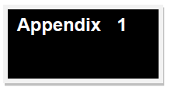
ROLES AND RESPONSIBILITIES

The Governing body should ensure that:
- The school meets the statutory responsibilities set out in Keeping Children Safe in Education (September 2021) and Working Together to Safeguard Children (February 2019).
- The school has a strategy for providing early help together with other agencies and supporting children and families by carrying out early help assessments, drawing upon Knowsley’s Helping Children Thrive model.
- The Safeguarding and Child Protection Policy is reviewed annually and available to parents/carers, normally via the school’s website.
- All adults working within the school are aware of the school’s code of conduct and this guidance is in keeping with the Guidance for Safer Working Practices for Adults Working with Children (Safer Recruitment Consortium, 2019).
- The school’s practice is reviewed in line with Local Authority guidance, Knowsley Safeguarding Children Board’s priorities and any actions identified in the Local Authority 175 Audit are completed.
- There is a named designated safeguarding lead who is a member of the school leadership team. There are colleagues trained to provide cover for the role.
- The school has procedures in keeping with Knowsley Safeguarding Children Board’s for dealing with any allegations made against any adult working within the school.
- There is a nominated governor, usually the chair, who is the case manager for managing any allegations against the headteacher.
- There is an additional nominated governor to liaise with the designated safeguarding lead and champion child protection/safeguarding on behalf of the safeguarding body.
- The school follows safer recruitment procedures, including the statutory pre-employment checks on all staff working with young people. The chair of governors and safeguarding governor together with the headteacher review the school’s single central record.
- The school itself is a safe environment where the views of children and families are listened to and where children are taught about safeguarding and how to keep themselves safe, including on the Internet or when using new technology. Any complaints about services lead to improvements in practice.
- The school will ensure there are appropriate filters and monitoring systems in place in respect of Internet use.
- It scrutinises the impact of the school’s training strategy so that all staff, including temporary staff and volunteers, are aware of the school’s safeguarding and child protection procedures. All staff must have child protection training, which is regularly updated.
- There is effective analysis of safeguarding data including bullying, attendance, exclusions, behaviour logs, pupils taken off roll, views and the progress and participation of vulnerable students.
- All safeguarding practices are quality assured by the leadership team, including the auditing of safeguarding records and the supervision of the designated safeguarding lead and other members of the safeguarding team.
- The governing body will appoint an appropriately trained designated teacher to promote the educational achievement of children who are looked after.

Governing bodies are accountable for ensuring the school has effective policies and procedures in place in line with local and national guidance, and for monitoring the school’s compliance with them. Neither the governing body nor individual governors have a role in dealing with individual child protection cases or the right to know the detail of cases (except when exercising their disciplinary functions in respect of allegations against a member of staff or investigating a complaint brought to their attention).

The Head Teacher will ensure that:
- The Single Central Record is maintained and up-to-date and the safer recruitment practices set out in Keeping Children Safe in Education 2021 are followed, including pre-employment checks. At least one member of every recruitment panel has attended safer recruitment training.
- Job descriptions and person specifications for all roles make specific reference to child protection and safeguarding.
- There is a listening culture within the school where both staff and children are able to raise concerns about poor or unsafe practices.
- Referrals are made to the Disclosure and Barring Service and / or the National College of School Leadership as appropriate.
- They liaise with the LADO where an allegation is made against a member of staff.
- The designated safeguarding lead has a job description in keeping with the requirements of Keeping Children Safe in Education 2021 and that sufficient time, training and support are allocated to this role, including the appointment of colleagues able to deputise for the designated safeguarding lead who have undertaken the same training.
- The curriculum provides opportunities to help students stay safe especially when on-line. Children should be aware of the support available to them.
- They quality assure the school’s child protection practices including the auditing of safeguarding records and the supervision of the designated safeguarding lead and other members of the safeguarding team to ensure that actions and decisions are reviewed appropriately.

Annex B: ROLE OF THE DESIGNATED SAFEGUARDING LEAD
Keeping Children Safe in Education September 2021.

Governing bodies, proprietors and management committees should appoint an appropriate senior member of staff, from the school or college leadership team, to the role of designated safeguarding lead. The designated safeguarding lead should take lead responsibility for safeguarding and child protection. This should be explicit in the role-holder’s job description. This person should have the appropriate status and authority within the school to carry out the duties of the post. They should be given the time, funding, training, resources and support to provide advice and support to other staff on child welfare and child protection matters, to take part in strategy discussions and inter-agency meetings – and/or to support other staff to do so – and to contribute to the assessment of children.

Deputy designated safeguarding leads

It is a matter for individual schools and colleges as to whether they choose to have one or more deputy designated safeguarding lead(s). Any deputies should be trained to the same standard as the designated safeguarding lead.

Whilst the activities of the designated safeguarding lead can be delegated to appropriately trained deputies, the ultimate lead responsibility for child protection, as set out above, remains with the designated safeguarding lead; this lead responsibility should not be delegated.

Manage referrals

The designated safeguarding lead is expected to:
- Refer cases of suspected abuse to the local authority children’s social care as required
- Support staff who make referrals to children’s social care
- Refer cases to the Channel programme where there is a radicalisation concern as required
- Support staff who make referrals to the Channel programme
- Refer cases where a person is dismissed or left due to risk/harm to a child to the Disclosure and Barring Service as required
- Refer cases where a crime may have been committed to the police as required.

Work with others

The designated safeguarding lead is expected to:
- Act as a point of contact with the three safeguarding partners.
- Liaise with the headteacher to inform him of issues especially ongoing enquiries under section 47 of the Children Act 1989 and police investigations
- As required, liaise with the “case manager” (as per Part four) and the designated officer(s) at the Local Authority for child protection concerns in case which concern a staff member
- Liaise with staff (especially pastoral support staff, school nurses, IT technicians, and SENCOs) on matters of safety and safeguarding (including online and digital safety) and when deciding whether to make a referral by liaising with relevant agencies.
- Act as a source of support, advice and expertise for staff.

Training

The designated safeguarding lead (and any deputies) should undergo training to provide them with the knowledge and skills required to carry out the role. This training should be updated at least every two years.

The designated safeguarding lead should undertake Prevent awareness training.

In addition to the formal training set out above, their knowledge and skills should be refreshed (this might be via e-bulletins, meeting other designated safeguarding leads, or simply taking time to read and digest safeguarding developments) at regular intervals, as required, but at least annually, to allow them to understand and keep up with any developments relevant to their role so they:
- Understand the assessment process for providing early help and statutory intervention, including local criteria for action and local authority children’s social care referral arrangements
- Have a working knowledge of how local authorities conduct a child protection case conference and a child protection review conference and be able to attend and contribute to these effectively when required to do so
- Ensure each member of staff has access to and understands the school or college’s Child Protection Policy and procedures, especially new and part time staff
- Are alert to the specific needs of children in need, those with special educational needs and young carers
- Are able to keep detailed, accurate, secure written records of concerns and referrals
- Understand and support the school or college with regards to the requirements of the Prevent duty and are able to provide advice and support to staff on protecting children from the risk of radicalisation
- Are able to understand the unique risks associated with online safety and be confident that they have the relevant knowledge and up-to-date capability required to keep children safe whilst they are online at school or college
- Can recognise the additional risks that children with SEN and disabilities (SEND) face online, for example from bullying, grooming and radicalisation and are confident they have the capability to support SEN children to stay safe online.
- Obtain access to resources and attend any relevant or refresher training courses
- Encourage a culture of listening to children and taking account of their wishes and feelings, among all staff, in any measures the school or college may put in place to protect them.

Raise awareness

The designated safeguarding lead should:

- Ensure the school or college’s child protection policies are known, understood and used appropriately
- Ensure the school or college’s Child Protection Policy is reviewed annually (as a minimum) and the procedures and implementation are updated and reviewed regularly, and work with governing bodies or proprietors regarding this
- Ensure the Child Protection Policy is available publicly and parents/carers are aware of the fact that referrals about suspected abuse or neglect may be made and the role of the school or college in this
- Link with KSCP to make sure staff are aware of training opportunities and the latest local policies on safeguarding
- Help promote educational outcomes by sharing the information about the welfare, safeguarding and child protection issues that children, including children with a social worker, are experiencing, or have experienced, with teachers and school and college leadership staff. Their role could include ensuring that the school or college, and their staff, know who these children are, understand their academic progress and attainment and maintain a culture of high aspirations for this cohort; supporting teaching staff to identify the challenges that children in this group might face and the additional academic support and adjustments that they could make to best support these children.

Child protection file

- Where children leave the school or college ensure their child protection file is transferred to the new school or college as soon as possible. This should be transferred separately from the main pupil file, ensuring secure transit and confirmation of receipt should be obtained.
- In addition to the child protection file, the designated safeguarding lead (or a deputy) should also consider if it would be appropriate to share any information with the new school or college in advance of a child leaving. For example, information that would allow the new school or college to continue supporting victims of abuse and have that support in place for when the child arrives.

Availability

- During term time the designated safeguarding lead (or a deputy) should always be available (during school or college hours) for staff in the school or college to discuss any safeguarding concerns. Whilst generally speaking the designated safeguarding lead (or deputy) would be expected to be available in person, it is a matter for individual schools and colleges, working with the designated safeguarding lead, to define what “available” means and whether in exceptional circumstances availability via phone and or Skype or other such media is acceptable.

- It is a matter for individual schools and colleges and the designated safeguarding lead to arrange adequate and appropriate cover arrangements for any out of hours/out of term activities.

Additional duties

In Knowsley the designated safeguarding lead may also act as champion for local/area initiatives such as Operation Encompass, CE single point of contact.
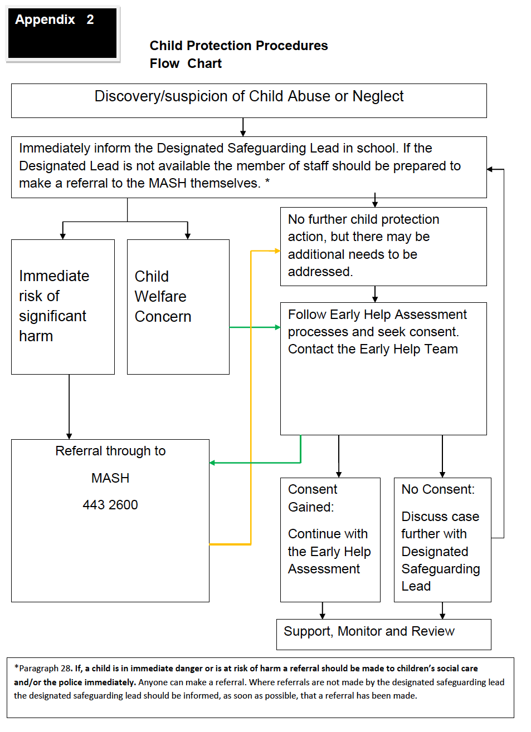

Where a child is suffering, or likely to suffer from harm, it is important that a referral to children’s social care (and if appropriate the police) is made immediately.

Para.62 - Keeping Children Safe in Education 2021.
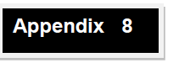
3
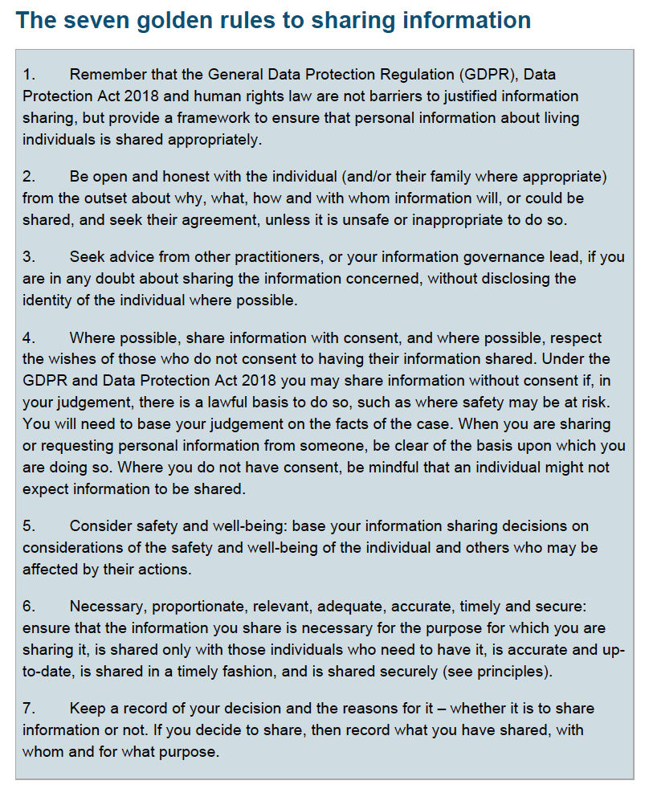
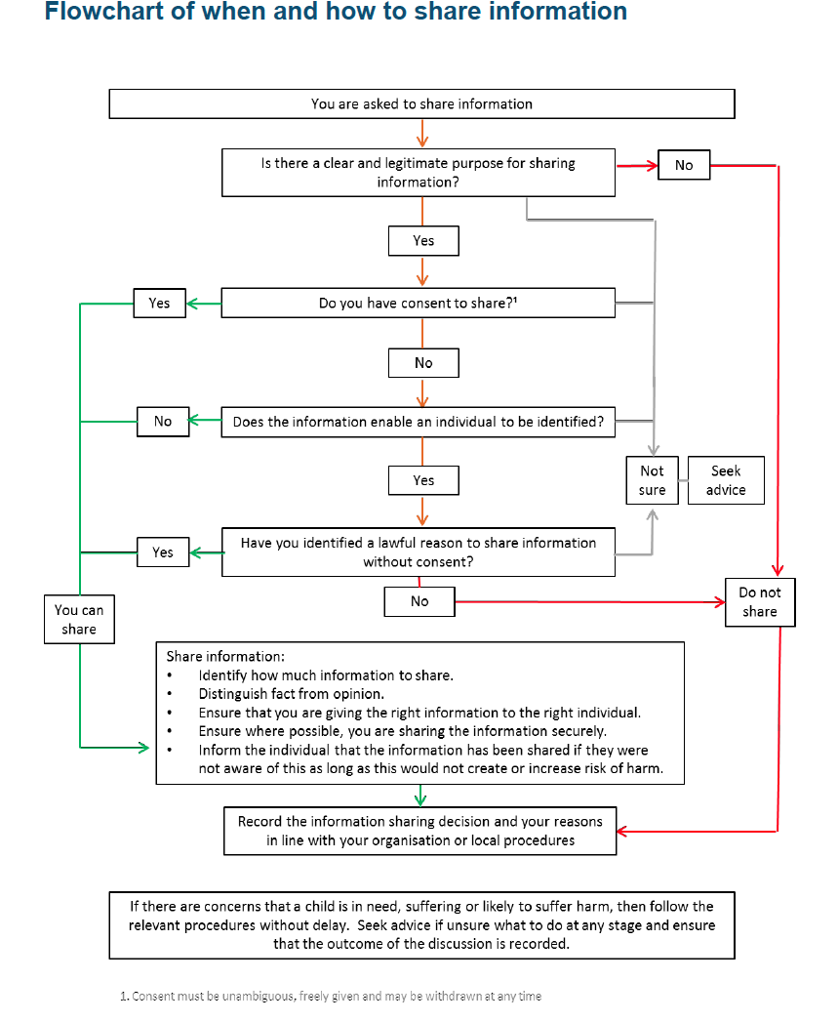
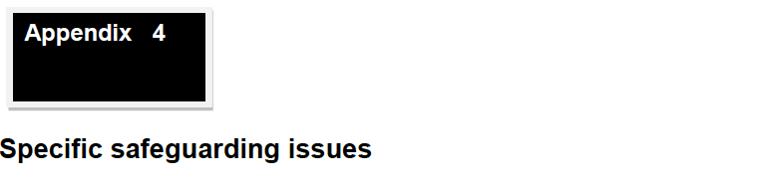
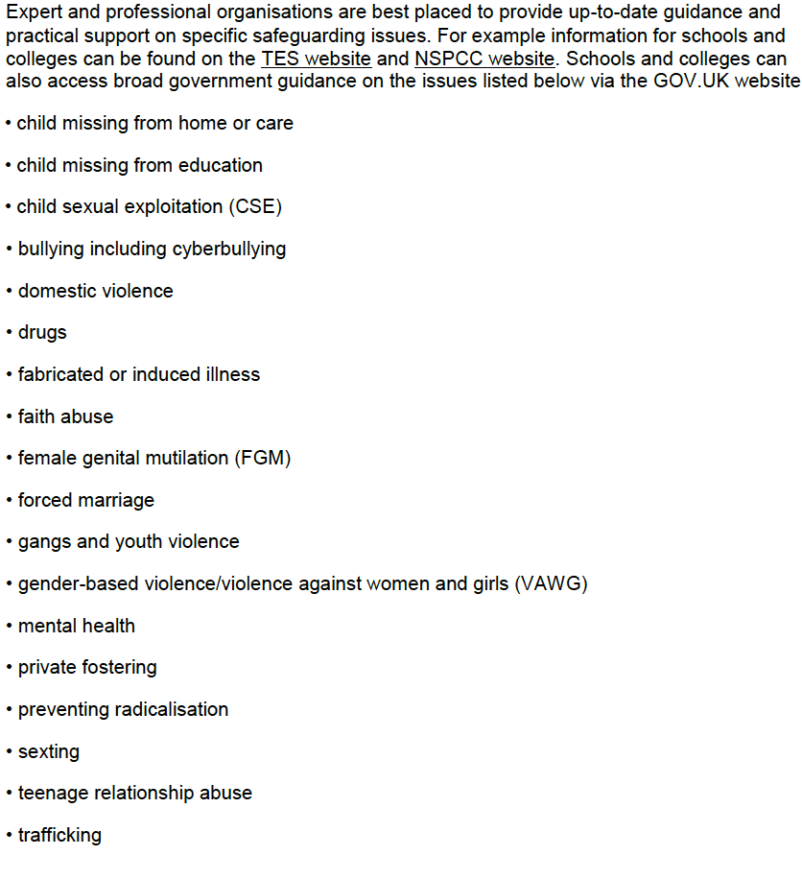

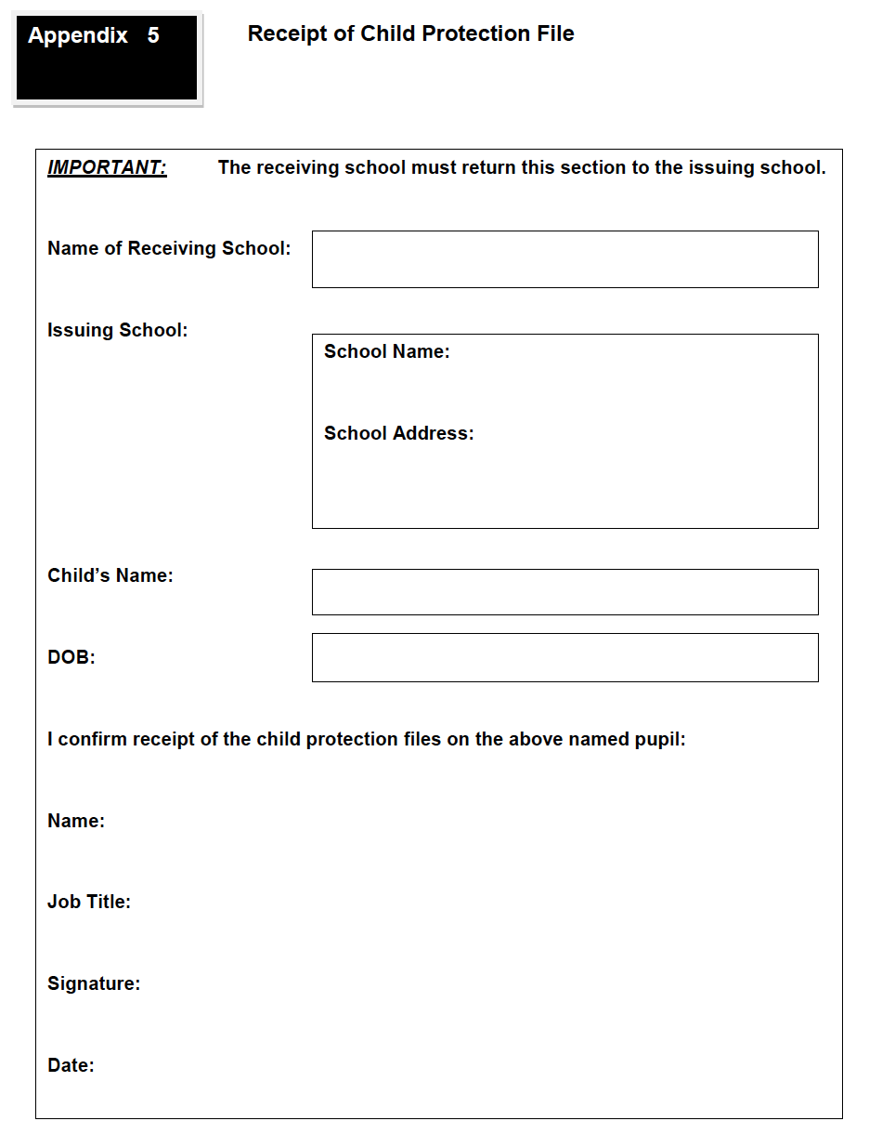

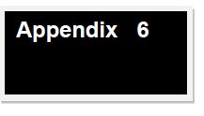
What is Child Abuse?

The following definitions are taken from Working Together to Safeguard Children HM Government (2019). In addition to these definitions, it should be understood that children can also be abused by honour-based violence, forced marriage or female genital mutilation.

What is abuse and neglect?
Abuse and neglect are forms of maltreatment of a child. Somebody may abuse or neglect a child by inflicting harm, or by failing to act to prevent harm. Children may be abused in a family or in an institutional or community setting, by those known to them or, more rarely, by a stranger. They may be abused by an adult or adults, or another child or children.

Physical abuse
Physical abuse may involve hitting, shaking, throwing, poisoning, burning or scalding, drowning, suffocating, or otherwise causing physical harm to a child. Physical harm may also be caused when a parent or carer fabricates the symptoms of, or deliberately induces, illness in a child.

Emotional abuse
The persistent emotional maltreatment of a child such as to cause severe and persistent adverse effects on the child’s emotional development. It may involve conveying to a child that they are worthless or unloved, inadequate, or valued only insofar as they meet the needs of another person. It may include not giving the child opportunities to express their views, deliberately silencing them or ‘making fun’ of what they say or how they communicate. It may feature age or developmentally inappropriate expectations being imposed on children. These may include interactions that are beyond a child’s developmental capability, as well as overprotection and limitation of exploration and learning, or preventing the child participating in normal social interaction. It may involve seeing or hearing the ill-treatment of another. It may involve serious bullying (including cyber bullying), causing children frequently to feel frightened or in danger, or the exploitation or corruption of children. Some level of emotional abuse is involved in all types of maltreatment of a child, although it may occur alone.

Sexual abuse
Involves forcing or enticing a child or young person to take part in sexual activities, not necessarily involving a high level of violence, whether or not the child is aware of what is happening. The activities may involve physical contact, including assault by penetration (for example, rape or oral sex) or non-penetrative acts such as masturbation, kissing, rubbing and touching outside of clothing. They may also include non-contact activities, such as involving children in looking at, or in the production of, sexual images, watching sexual activities, encouraging children to behave in sexually inappropriate ways, or grooming a child in preparation for abuse. Sexual abuse can take place online, and technology can be used to facilitate offline abuse. Sexual abuse is not solely perpetrated by adult males. Women can also commit acts of sexual abuse, as can other children.

Neglect
Neglect is the persistent failure to meet a child’s basic physical and/or psychological needs, likely to result in the serious impairment of the child’s health or development. Neglect may occur during pregnancy as a result of maternal substance abuse. Once a child is born, neglect may involve a parent or carer failing to:
∙ Provide adequate food, clothing and shelter (including exclusion from home or
abandonment)
∙ Protect a child from physical and emotional harm or danger
∙ Ensure adequate supervision (including the use of inadequate care-givers)
∙ Ensure access to appropriate medical care or treatment. It may also include neglect of, or
unresponsiveness to a child’s basic emotional needs.

Indicators of Abuse

Neglect

The nature of neglect
Neglect is a lack of parental care but poverty and lack of information or adequate services can be contributory factors. Far more children are registered to the category of neglect on Child Protection Plans than to the other categories. As with abuse, the number of children experiencing neglect is likely to be much higher than the numbers on the plans.

Neglect can include parents or carers failing to:
• Provide adequate food, clothing and shelter
• Protect a child from physical and emotional harm or danger
• Ensure adequate supervision or stimulation
• Ensure access to appropriate medical care or treatment.

NSPCC research has highlighted the following examples of the neglect of children under the age of 12:
• Frequently going hungry
• Frequently having to go to school in dirty clothes
• Regularly having to look after themselves because of parents being away or having problems
such as drug or alcohol misuse
• Being abandoned or deserted
• Living at home in dangerous physical conditions
• Not being taken to the doctor when ill
• Not receiving dental care

Neglect is a difficult form of abuse to recognise and is often seen as less serious than other categories. It is, however, very damaging: children who are neglected often develop more slowly than others and may find it hard to make friends and fit in with their peer group.
Neglect is often noticed at a stage when it does not pose a risk to the child. The duty to safeguard and promote the welfare of children (What to do if you’re worried a child is being abused, March 2015 – gov.uk) would suggest that an appropriate intervention or conversation at this early stage can address the issue and prevent a child continuing to suffer until it reaches a point when they are at risk of harm or in significant need.

Neglect is often linked to other forms of abuse, so any concerns school staff have should at least be discussed with the DSL.

Indicators of neglect
The following is a summary of some of the indicators that may suggest a child is being abused or is at risk of harm. It is important to recognise that indicators alone cannot confirm whether a child is being abused. Each child should be seen in the context of their family and wider community and a proper assessment carried out by appropriate persons. What is important to keep in mind is that if you feel unsure or concerned, do something about it. Don’t keep it to yourself.

Physical indicators of neglect
- Constant hunger and stealing food
- Poor personal hygiene - unkempt, dirty or smelly
- Underweight
- Dress unsuitable for weather
- Poor state of clothing
- Illness or injury untreated

Behavioural indicators of neglect
- Constant tiredness
- Frequent absence from school or lateness
- Missing medical appointments
- Isolated among peers
- Frequently unsupervised
- Stealing or scavenging, especially food
- Destructive tendencies

Emotional Abuse

The nature of emotional abuse
Most harm is produced in low warmth, high criticism homes, not from single incidents. Emotional abuse is difficult to define, identify/recognise and/or prove. Emotional abuse is chronic and cumulative and has a long-term impact. All kinds of abuse and neglect have emotional effects although emotional abuse can occur by itself. Children can be harmed by witnessing someone harming another person – as in domestic violence.

It is sometimes possible to spot emotionally abusive behaviour from parents and carers to their children, by the way that the adults are speaking to, or behaving towards children. An appropriate challenge or intervention could affect positive change and prevent more intensive work being carried out later on.

Indicators of emotional abuse

Developmental issues
- Delays in physical, mental and emotional development
- Poor school performance
- Speech disorders, particularly sudden disorders or changes

Behaviour
- Acceptance of punishment which appears excessive
- Over-reaction to mistakes
- Continual self-deprecation (“I’m stupid, ugly, worthless” etc.)
- Neurotic behaviour (such as rocking, hair-twisting, thumb-sucking)
- Self-mutilation
- Suicide attempts
- Drug/solvent abuse
- Running away
- Compulsive stealing, scavenging
- Acting out
- Poor trust in significant adults
- Regressive behaviour – e.g., wetting
- Eating disorders
- Destructive tendencies
- Neurotic behaviour
- Arriving early at school, leaving late

Social issues
- Withdrawal from physical contact
- Withdrawal from social interaction
- Over-compliant behaviour
- Insecure, clinging behaviour
- Poor social relationships

Emotional responses
- Extreme fear of new situations
- Inappropriate emotional responses to painful situations (“I deserve this”)
- Fear of parents being contacted
- Self-disgust
- Low self-esteem
- Unusually fearful with adults
- Lack of concentration, restlessness, aimlessness
- Extremes of passivity or aggression

Physical Abuse

The nature of physical abuse
Most children collect cuts and bruises quite routinely as part of the rough and tumble of daily life. Clearly, it is not necessary to be concerned about most of these minor injuries but accidental injuries normally occur on the bony prominences – e.g.shins. Injuries on the soft areas of the body are more likely to be inflicted intentionally and should therefore make us more alert to other concerning factors that may be present.

A body map can assist in the clear recording and reporting of physical abuse; one can be found on CPOMS. The body map should only be used to record observed injuries and no child should be asked to remove clothing by a member of staff.

Indicators of physical abuse / factors that should increase concern
- Multiple bruising or bruises and scratches (especially on the head and face)
- Clusters of bruises – e.g. fingertip bruising (caused by being grasped)
- Bruises around the neck and behind the ears – the most common abusive injuries are to the head
- Bruises on the back, chest, buttocks, or on the inside of the thighs
- Marks indicating injury by an instrument – e.g., linear bruising (stick), parallel bruising (belt), marks of a buckle
- Bite marks
- Deliberate burning may also be indicated by the pattern of an instrument or object – e.g. electric fire, cooker, cigarette
- Scalds with upward splash marks or tide marks
- Untreated injuries
- Recurrent injuries or burns
- Bald patches

In the social context of the school, it is normal to ask about a noticeable injury. The response to such an enquiry is generally light-hearted and detailed. So, most of all, concern should be increased when:

- The explanation given does not match the injury
- The explanation uses words or phrases that do not match the vocabulary of the child (adult’s words)
- No explanation is forthcoming
- The child (or the parent/carer) is secretive or evasive
- The injury is accompanied by allegations of abuse or assault

You should be concerned if the child or young person:
- Is reluctant to have parents/carers contacted
- Runs away or shows fear of going home
- Is aggressive towards themselves or others
- Flinches when approached or touched
- Is reluctant to undress to change clothing for sport
- Wears long sleeves during hot weather
- Is unnaturally compliant in the presence of parents/carers
- Has a fear of medical help or attention.
- Admits to a punishment that appears excessive

Sexual Abuse

The nature of sexual abuse
Sexual abuse is often perpetrated by people who are known and trusted by the child – e.g. relatives, family friends, neighbours, babysitters, people working with the child in school, faith settings, clubs or activities. Children can also be subject to child sexual exploitation.

Characteristics of child sexual abuse
- It is often planned and systematic – people do not sexually abuse children by accident, though sexual abuse can be opportunistic.
- Grooming the child – people who abuse children take care to choose a vulnerable child and often spend time making them dependent.
- Grooming the child’s environment – abusers try to ensure that potential adult protectors (parents and other carers especially) are not suspicious of their motives

Most people who sexually abuse children are men, but some women sexually abuse too.

Indicators of sexual abuse

Physical observations
- Damage to genitalia, anus or mouth
- Sexually transmitted diseases
- Unexpected pregnancy, especially in very young girls
- Soreness in genital area, anus or mouth and other medical problems such as chronic itching
- Unexplained recurrent urinary tract infections and discharges or abdominal pain

Behavioural observations
- Sexual knowledge inappropriate for age
- Sexualised behaviour or affection inappropriate for age
- Sexually provocative behaviour/promiscuity
- Hinting at sexual activity
- Inexplicable decline in school performance
- Depression or other sudden apparent changes in personality
- Lack of concentration, restlessness, aimlessness
- Socially isolated or withdrawn
- Overly-compliant behaviour
- Acting out, aggressive behaviour
- Poor trust or fear concerning significant adults
- Regressive behaviour
- Onset of wetting, by day or night; nightmares
- Onset of insecure, clinging behaviour
- Arriving early at school, leaving late, running away from home
- Suicide attempts, self-mutilation, self-disgust
- Suddenly drawing sexually explicit pictures
- Eating disorders or sudden loss of appetite or compulsive eating
- Regressing to younger behaviour patterns such as thumb sucking or bringing out discarded cuddly toys
- Become worried about clothing being removed
- Trying to be ‘ultra-good’ or perfect; overreacting to criticism

Child Sexual Exploitation (CSE)

Sexual exploitation can be very difficult to identify. Warning signs can easily be mistaken for 'normal' teenage behaviour.

Children and young people who are being sexually exploited may:

- Go missing from home, care or education or regularly return home late
- Stay out overnight with no reasonable explanation
- Exclusion or unexplained absences from school
- Appear with unexplained gifts, possessions or money that can’t be accounted for
- Reduce contact with family friends and other support networks
- Be secretive about their mobile ‘phone or have more than one ‘phone
- Be involved in controlling/abusive relationships, intimidated and fearful of certain people or situations
- Hang out with groups of older people, or antisocial groups, or with other vulnerable peers
- Associate with other young people involved in sexual exploitation or be seen in CSE hotspots
- Get involved in gangs, gang fights, gang membership
- Have much older boyfriends or girlfriends
- Get into cars with unknown adults
- Use drugs/alcohol
- Have poor self-image, eating disorders or self-harm
- Display inappropriate sexualised behaviour, such as over-familiarity with strangers, dressing in a sexualised manner or sending sexualised images by ‘phone (sexting)
- Experience health problems that may indicate sexually transmitted infections
- Spend time at places of concern, such as hotels or known brothels
- Not know where they are, because they have been moved around the country
- Be involved in petty crime such as shoplifting
- Have unexplained physical injuries, for example bruising or cigarette burns
- Have a changed physical appearance, for example lost weight

Child Criminal Exploitation / County Lines

A young person’s involvement in county lines activity often leaves signs. A young person might exhibit some of these signs, either as a member or as an associate of a gang dealing drugs. Any sudden changes in a young person’s lifestyle should be discussed with them. Some indicators of county lines involvement and exploitation are listed below, with those at the top of particular concern:

- Frequent missing episodes and been found out of area
- Found with large quantities of drugs or weapons
- Found with drugs inside rectum or vagina
- Unexplained amounts of money, mobiles, credit, clothing, jewellery, new hair cut or other items/gifts
- Returned from missing episodes with injuries, or dishevelled
- Change in behaviour; more secretive/withdrawn/isolated from peers or not mixing with usual friends
- Unexplained absences from, or not engaged in school/college/training/work
- Increasingly disruptive, hostile or physically aggressive at home or school Including use of sexualised language and language in relation to drug dealing and/or violence
- Expressions around invincibility or not caring about what happens to them
- Increased interest in making money
- Reports being taken to parties, people’s houses, unknown areas, hotels, nightclubs, takeaways or out of area by unknown adults
- Increasing use of drugs or alcohol
- Fear of reprisal from “gang‟ members or violence from young people or adults
- Having multiple mobile ‘phones, SIM cards or use of a ‘phone that causes concern - multiple callers or more texts/pings than usual
- Possession of hotel keys/cards or keys to unknown premises
- Disclosure of sexual/physical assault followed by withdrawal of allegation
- Abduction or forced imprisonment
- Entering or leaving vehicles cars with unknown adults
- Receiving rewards of money or goods for introducing peers
- Self-harm or significant changes in emotional well-being
- Agencies unable to engage
- New peer groups and/or relationships
- Relationships with controlling/older individuals or groups
- Parental concerns
- Repeated STIs and/or pregnancy
- Increase referrals to agencies for other known peers
- Multiple referrals for incidents in the same location

Female Genital Mutilation (FGM)

A girl at immediate risk of FGM may not know what's going to happen but she might talk about or you may become aware of:

- Her being withdrawn from PSHE lessons
- Being taken on a long holiday abroad or going 'home' to visit family
- A relative or cutter visiting from abroad
- A special occasion or ceremony to 'become a woman' or get ready for marriage
- A female relative being cut – a sister, cousin, or an older female relative such as a mother or aunt

A girl who’s had FGM may:

- Have difficulty walking, standing or sitting
- Spend longer in the bathroom or toilet
- Have frequent urinary, bladder, menstrual or stomach problems
- Avoid physical exercise or ask to be excused from PE lessons without a GP’s letter
- Have increased emotional or psychological needs, for example, appearing withdrawn, anxious or depressed
- Have unusual behaviour after a prolonged or repeated absence from school or college
- Be particularly reluctant to undergo normal medical examinations
- Ask for help, but may not be explicit about the problem due to embarrassment or fear

7

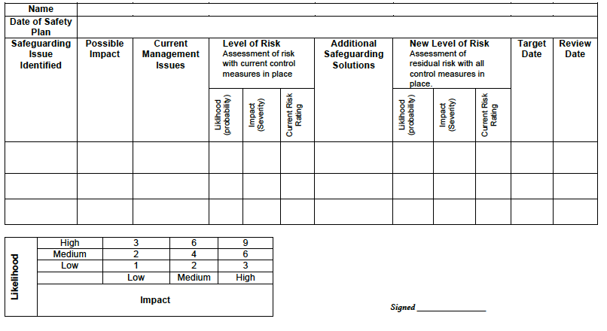

INDICATORS OF VULNERABILITY TO RADICALISATION

1. Radicalisation refers to the process by which a person comes to support terrorism and forms of extremism leading to terrorism.

2. Extremism is defined by the Government in the Prevent Strategy as:

Vocal or active opposition to fundamental British values, including democracy, the rule of law, individual liberty and mutual respect and tolerance of different faiths and beliefs. We also include in our definition of extremism calls for the death of the members of our armed forces, whether in this country or overseas.

3. Extremism is defined by the Crown Prosecution Service as:

The demonstration of unacceptable behaviour by using any means or medium to express views which:
- Encourage, justify or glorify terrorist violence in furtherance of particular beliefs
- Seek to provoke others to terrorist acts
- Encourage other serious criminal activity or seek to provoke others to serious criminal acts
- Foster hatred, which might lead to community violence in the UK.

4. There is no such thing as a “typical extremist” - those who become involved in extremist actions come from a range of backgrounds and experiences, and most individuals, even those who hold radical views, do not become involved in violent extremist activity.

5. Pupils may become susceptible to radicalisation through a range of social, personal and environmental factors – it is known that violent extremists exploit vulnerabilities in individuals to drive a wedge between them and their families and communities. It is vital that school staff are able to recognise those vulnerabilities.

6. Indicators of vulnerability include:

- Identity Crisis – the student/pupil is distanced from their cultural/religious heritage and experiences discomfort about their place in society
- Personal Crisis – the student/pupil may be experiencing family tensions; a sense of isolation; and low self-esteem; they may have dissociated from their existing friendship group and become involved with a new and different group of friends; they may be searching for answers to questions about identity, faith and belonging
- Personal Circumstances – migration; local community tensions; and events affecting the student/pupil’s country or region of origin may contribute to a sense of grievance that is triggered by personal experience of racism or discrimination or aspects of Government policy
- Unmet Aspirations – the student/pupil may have perceptions of injustice; a feeling of failure; rejection of civic life
- Experiences of Criminality – which may include involvement with criminal groups, imprisonment, and poor resettlement/reintegration
- Special Educational Needs – the student/pupil may experience difficulties with social interaction, empathy with others, understanding the consequences of their actions and awareness of the motivations of others.

However, this list is not exhaustive, nor does it mean that all young people experiencing the above are at risk of radicalisation for the purposes of violent extremism.

7. Warning signs of radicalisation:
- Becoming argumentative and unwilling to listen to other people’s points of view. Refusal to engage with or becoming abusive to peers who are different to themselves, perhaps on the basis of race, religion, gender or sexuality. Becoming susceptible to conspiracy theories and feelings of persecution
- Changes in friendship groups and appearance: young people may distance themselves from friends, both online and offline, convert to a new religion, significantly change their appearance or clothing, and reject activities they used to enjoy
- A change of online identity, including own social media name or profile image. This may include two parallel online profiles – one being the ‘normal’ or old self, and the other being an extremist identity, often with another name. Spending excessive amounts of time online or on the phone, and being secretive and reluctant to discuss activities and/or whereabouts.
8. More critical risk factors could include:

- Expressing sympathy for extremist ideologies and groups
- Accessing violent extremist websites, especially those with a social networking element such as Facebook and Twitter
- Possessing or accessing violent extremist literature
- Using extremist narratives and a global ideology to explain personal disadvantage
- Justifying the use of violence to solve societal issues
- Being in contact with extremist recruiters
- Joining or seeking to join extremist organisations
- Experiencing a high level of social isolation resulting in issues of identify crisis and/or personal crisis.

9

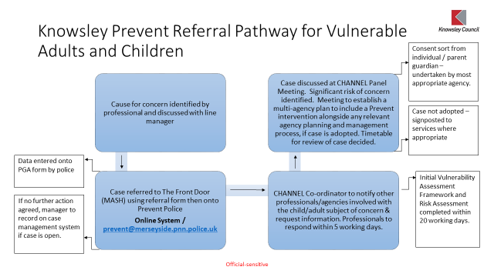

USEFUL CONTACTS

Key Personnel | Name | Telephone Number
DSL(s) | Miss Lynne Jackson  Mr Brian Bradley  Mr Tony McGuinness | 0151 477 8751 / 07557 258851  0151 477 8740 / 07557 260015  0151 477 8753
Named Governor for Safeguarding |  | Please contact through All Saints’ switchboard  0151 477 8740
Chair of Governors | Mr John Thornhill | Please contact through All Saints’ switchboard  0151 477 8740  jthornhill@allsaintschs.org.uk
Knowsley MASH | First point of contact for the Early Help Team, Family First and Children’s Social Care | 0151 443 2600
Out of hours Social Care | Emergency Duty Team | 0151 443 2600
Local Authority Designated Officer (LADO) | Lindsey Heaton | 07766780354  or via MASH on 0151 443 2600  or email CPconference@knowlsey.gov.uk.
Local Authority Education Safeguarding Officer | Vicki Clements | 0151 443 2969  07927 756803
Knowsley Early Team  (Kirkby) | Sarah Lippa | 0151 443 2873  07775 221911
School Nurse | Jen Atkinson | 0151 244 3066 (St Chad’s)  07824 821119
Safer Schools Police Officer | PC Jane McGuirk | Monday, Tuesday & Friday A.M  0151 477 8740 Ext 2013  Wednesday, Thursday & Friday P.M  0151 477 8710
NSPCC Helpline | Help for adults concerned about a child | 0808 800 5000
Childline | Help for children and young people | 0800 1111

